**CONTENTS**

|  |  |  |
| --- | --- | --- |
| **CHAPTER NO.** | **TABLE OF CONTENTS** | **PAGE NO.** |
| 1.  2.  3.  4.  5.  6.  7.  8.  9.    10. | ABSTRACT  INTRODUCTION   * 1. . LITERATURE SURVEY   2. . MODULES DESCRIPTION   STUDY OF THE SYSTEM  2.1. FEASABILITY STUDY  2.2. EXISTING SYSTEM  2.3. PROPOSED SYSTEM  SYSTEM SPECIFICATION  3.1. HARDWARE REQUIREMENTS  3.2. SOFTWARE REQUIREMENTS  SYSTEM DEVELOPEMENT ENVIRONMENT   * 1. . INTRODUCTION TO JAVA   2. . SERVLETS/ JSP   3. . JDBC   SYSTEM DESIGN & DEVELOPMENT   1. . INTRODUCTION 2. . NORMALIZATION 3. . E-R DIAGRAM 4. . DATA DICTIONARY 5. . DATA FLOW DIAGRAM 6. . ACTIVITY DIAGRAM 7. . USE CASE DIAGRAM 8. . SEQUENCE DIAGRAM 9. . CLASS DIAGRAM   SAMPLE SOURCE CODE  SCREEN LAYOUT  SYSTEM TESTING AND IMPLEMENTATION  CONCLUSION  BIBLIOGRAPHY | iii  1  9  13  14  38  62  68  78 |

**INTRODUCTION**

**1.1 Problem Definition**

The project will be used by the students to apply for bus pass and also to get the bus pass renewal in online .If we consider the current system then the students has to wait for long time standing in queue to apply for bus pass near the counters. Even if they want to get their bus pass get renewal then they have follow the same procedure of waiting for long hours near the counters. The current procedure is a time consuming procedure.

The current system leads to the inconvenience and dissatisfactory of the users. People have to travel to the nearby and respective Bus Stops and to apply for bus pass and also for the bus pass renewal. It requires a lot of man power.

Hence to overcome the above problems a system is being developed. This system reduced the time in issue/renew of bus-pass considerably, thus leading to convenience & satisfaction to the commuters. It has reduced the time taken to issue/renew bus-passes from 25 – 30 minutes to 3 – 5 minutes. Now, there are almost no queues on bus-pass issue centers. With computerization, possibility of fake/duplicate passes has reduced considerably. It has led to commuter satisfaction by reduction in time and fatigue in getting the pass issued. This online bus pass registration application will help students save their time and renewal bus passes without standing in a line for hours near counters. Initially students need to register with the application by submitting details of photo address proof, and required details and submit through online. They will verify your details and if they are satisfied they will approve bus pass. You can even renewal using credit card or other wire transfer methods.

**1.2 Project Analysis:**

**Integrated Ticket system Project** is a real time project which is useful for the students who Are facing problems with the current manual work of bus pass   Registration and renewal. It also increases the validity period,   frequently Warns to the student before completion of his validity period by sending sms or mails. His / Her Renewal or Registration can be done using a voucher or even by a credit card.

This online bus pass registration application will help students save their time and renewal bus passes without standing in a line for hours near counters. Initially students need to register with the application by submitting details of photo address proof, and required details and submit through online. They will verify your details and if they are satisfied they will approve bus pass. You can even renewal using credit card or other wire transfer methods.

This application consists of following modules

1. Online Bus-Pass Registration
2. Online Bus-Pass Renewal
3. Online Pass Schemes
4. Status for Registrations & Renewals
5. Search Routes & Fares
6. Reports

**Module I:** Online Bus-Pass Registration:

Different types of bus pass registration for the people of the twin cities. In this module initially students need to register with the application by submitting details of photo, address proof and required details and submit through online. They will verify your details and if they are satisfied they will approve bus pass.

**Module II:** Online Bus-Pass Renewal:

Different types of bus pass renewals for the people of the twin cities. In this module students have to Login to the website and apply for Renewal and they have to check their status which shows whether their bus pass is renewal or not. You can even renewal using credit card or other wire transfer methods. Once the bus pass gets renewal Amount is deducted automatically.

**Module III:** Online Pass Schemes:

Different types of bus pass schemes for the people of the twin cities. In this module User can view different schemes which are available

**Module IV:** Status for Registrations & Renewals:

Checking the status of registrations and renewal of passes. This module is very useful as students will get to know what is their status is. In this module Admin will verify the details of user and generates status either as Accepted or rejected. Based on this status information further actions will be carried out such as deduction of bus pass amount from the user account.

**Module V:** Search Routes & Fares:

To know the fares and routes for different bus pass Registrations. In this module different routes and fares are provided for the user so that he can easily come to know the routes and their fares.

**Module VI:** Reports:

The user can give suggestions regarding our website or can give any complaints.

**2. LITERATURE SURVEY**

**2.1 Existing System:**

In existing system the students has to wait for long time standing in queue to apply for bus pass near the counters. Even if they want to get their bus pass get renewal then they have follow the same procedure of waiting for long hours near the counters. The current procedure is a time consuming procedure. The current system leads to the inconvenience and dissatisfactory of the users. People have to travel to the nearby and respective Bus Stops and to apply for bus pass and also for the bus pass renewal. It requires a lot of man power.

**2.2 Disadvantages Of Existing System:**

* Takes lot of time in issue/renew of bus-pass considerably.
* Leads to the inconvenience and dissatisfactory of the users.
* The time taken in the issue/renew of bus-pass considerably is 25 – 30 minutes.
* Students have to wait for long time standing in queue near counters.

**2.3 Proposed System:**

The Proposed system will help students save their time and renewal bus passes without standing in a line for hours near counters. Initially students need to register with the application by submitting details of photo, address proof, and required details and submit through online. They will verify your details and if they are satisfied they will approve bus pass. You can even renewal using credit card or other wire transfer methods.

**2.4 Advantages Of Proposed System:**

* Has reduced the time in issue/renew of bus-pass considerably.
* Leads to the convenience and satisfactory of the users.
* The time taken in the issue/renew of bus-pass considerably is 3-5 minutes.
* Now, there are almost no queues on bus-pass issue centers.
* With computerization, possibility of fake/duplicate passes has reduced considerably.

**2.5 Feasibility Study**

A feasibility study is an evaluation of the proposal is to determine the difficulty in carry out a task. Generally a feasibility study precedes technical development and project implementation in other words, a feasibility study is a evaluation (or) analysis of the potential impact of the proposed project.

* **Types Of Feasibility:**
* **Technology Feasibility:**

The assessment is based the outline design of system required in terms of input processes, output, fields, programs and procedures. This can be quantified in terms of volumes of data trends, frequency of updating etc in order to estimate whether the new system will perform adequately or not. Technology feasibility is carried to determine whether the company has capability in terms of software, hardware, personal and expertise the completion of project.

* **ECONOMIC FEASIBILITY:**

Economic feasibility analysis is the most frequently used method for evaluating the effectiveness of new system, commonly cost of benefit analysis. The procedure is to determine the benefits outweigh cost then the decision is made to design and implemented the system entrepreneur must accurately weigh the cost is a benefit before taking an action.

* **LEGAL FEASIBILITY:**

Determines whether the proposed system conflicts with legal requirements eg-a data processing system comply with a local protection acts.

* **OPERATING FEASIBILITY:**

It is a measure how we are proposed system solves the problems and takes advantages of the opportunity identify during scope definition and how it satisfies the requirements identified the requirements analysis phase of system development.

* **SCHEDULE FEASIBILITY:**

A project will fail if it takes too long to be completion before it is used. Typically this means estimating how long the system will take to develop and if it can be completed in a given time period using so many methods like payback period. Schedule feasibility is a measure how the responsible the project timetable is.

**3. SYSTEM ANALYSIS AND DESIGN**

**3.1 System Requirements Specifications**

* **Software Requirements:**

Operating System : Windows 7

Technology : Java/J2EE (Servlets, JSP, JDBC)

Web Technologies : Html, JavaScript, CSS

Web Server : Tomcat 7.0

Database :Oracle 10g Express Edition

Software’s : JDK 1.6

* **Hardware Requirements:**

Hardware : Pentium based systems with a minimum of P4

RAM : 1GB (minimum)

**4. DESIGN**

**4.1 UML Diagrams**

The unified modeling language allows the software engineer to express an analysis model using the modeling notation that is governed by a set of syntactic semantic and pragmatic rules.

A UML system is represented using five different views that describe the system from distinctly different perspective. Each view is defined by a set of diagram, which is as follows.

1. **User model view**

* This view represents the system from the users perspective.
* The analysis representation describes a usage scenario from the end-users perspective.

1. **Structural model view**

* In this model the data and functionality are arrived from inside the system.
* This model view models the static structures.

1. **Behavioral Model View**

It represents the dynamic of behavioral as parts of the system, depicting the interactions of collection between various structural elements described in the user model and structural model view.

1. **Implementation Model View**

In this the structural and behavioral as parts of the system are represented as they are to be built.

1. **Environmental Model View**

In this the structural and behavioral aspects of the environment in which the system is to be implemented are represented.

UML is specifically constructed through two different domains they are:

* UML Analysis modeling, this focuses on the user model and structural model views of the system.
* UML design modeling, which focuses on the behavioral modeling, implementation modeling and environmental model views.
* Use case Diagrams represent the functionality of the system from a user’s point of view. Use cases are used during requirements elicitation and analysis to represent the functionality of the system. Use cases focus on the behavior of the system from external point of view.
* Actors are external entities that interact with the system. Examples of actors include users like administrator, bank customer …etc., or another system like central database.

**The UML Is a Language for Documenting:**

A healthy software organization produces all sorts of artifacts in addition to raw executable code. These artifacts include (but are not limited to)

* Requirements
* Architecture
* Design
* Source code
* Project plans
* Tests
* Prototypes
* Releases

Depending on the development culture, some of these artifacts are treated more or less formally than others. Such artifacts are not only the deliverables of a project, they are also critical in controlling, measuring, and communicating about a system during its development and after its deployment.

The UML addresses the documentation of a system's architecture and all of its details. The UML also provides a language for expressing requirements and for tests. Finally, the UML provides a language for modeling the activities of project planning and release management.

**Applications:**

The UML is intended primarily for software-intensive systems. It has been used effectively for such domains as

* Enterprise information systems
* Banking and financial services
* Telecommunications
* Transportation
* Defense/aerospace
* Retail
* Medical electronics
* Scientific
* Distributed Web-based services

The UML is not limited to modeling software. In fact, it is expressive enough to model no software systems, such as workflow in the legal system, the structure and behavior of a patient healthcare system, and the design of hardware.

* **A Conceptual Model of the UML:**

To understand the UML, you need to form a conceptual model of the language, and this requires learning three major elements: the UML's basic building blocks, the rules that dictate how those building blocks may be put together, and some common mechanisms that apply throughout the UML. Once you have grasped these ideas, you will be able to read UML models and create some basic ones. As you gain more experience in applying the UML, you can build on this conceptual model, using more advanced features of the language.

* **Building Blocks of the UML**:

The vocabulary of the UML encompasses three kinds of building blocks:

* Things
* Relationships
* Diagrams

Things are the abstractions that are first-class citizens in a model; relationships tie these things together; diagrams group interesting collections of things.

* **Things in the UML**:

There are three kinds of things in the UML:

* Structural things
* Behavioral things
* Grouping things
* **Relationships in the UML:**

There are four kinds of relationships in the UML:

* + - Dependency
    - Association
    - Generalization
    - Realization

These relationships are the basic relational building blocks of the UML.

1. First, a dependency is a semantic relationship between two things in which a change to one thing may affect the semantics of the other thing. Graphically, a dependency is rendered as a dashed line, possibly directed, and occasionally including a label.

2. Second, an association is a structural relationship that describes a set of links, a link being a connection among objects. Aggregation is a special kind of association, representing a structural relationship between a whole and its parts. Graphically, an association is rendered as a solid line, possibly directed, occasionally including a label, and often containing other adornments.

3. Third, a generalization is a specialization/generalization relationship in which objects of the specialized element (the child) are substitutable for objects of the generalized element (the parent). Graphically, a generalization relationship is rendered as a solid line with a hollow arrowhead pointing to the parent.

4. Fourth, a realization is a semantic relationship between classifiers, wherein one classifier specifies a contract that another classifier guarantees to carry out. Graphically, a realization relationship is rendered as a cross between a generalization and a dependency relationship.

These four elements are the basic relational things you may include in a UML model. There are also variations on these four, such as refinement, trace, include, and extend (for dependencies).

* **Diagrams in the UML**

A **diagram** is the graphical presentation of a set of elements, most often rendered as a connected graph of vertices (things) and arcs (relationships). You draw diagrams to visualize a system from different perspectives, so a diagram is a projection into a system. For all but the most trivial systems, a diagram represents an elided view of the elements that make up a system. The same element may appear in all diagrams, only a few diagrams (the most common case), or in no diagrams at all (a very rare case). In theory, a diagram may contain any combination of things and relationships. In practice, however, a small number of common combinations arise, which are consistent with the five most useful views that comprise the architecture of a software-intensive system. For this reason, the UML includes nine such diagrams:

* Class diagram
* Object diagram
* Use case diagram
* Sequence diagram
* Collaboration diagram
* State chart diagram
* Activity diagram
* Component diagram
* Deployment diagram

A class diagram shows a set of classes, interfaces, and collaborations and their relationships. These diagrams are the most common diagram found in modeling object-oriented systems. Class diagrams address the static design view of a system.

An object diagram shows a set of objects and their relationships. Object diagrams represent static snapshots of instances of the things found in class diagrams. These diagrams address the static design view or static process view of a system as do class diagrams, but from the perspective of real or prototypical cases.

A sequence diagram is an interaction diagram that emphasizes the time-ordering of messages; a collaboration diagram is an interaction diagram that emphasizes the structural organization of the objects that send and receive messages. Sequence diagrams and collaboration diagrams are isomorphic, meaning that you can take one and transform it into the other.

Both sequence diagrams and collaboration diagrams are kinds of interaction diagrams. A collaboration diagram shows an interaction, consisting of a set of objects and their relationships, including the messages that may be dispatched among them. Interaction diagrams address the dynamic view of a system.

A use case diagram shows a set of use cases and actors (a special kind of class) and their relationships. Use case diagrams address the static use case view of a system. These diagrams are especially important in organizing and modeling the behaviors of a system

A statechart diagram shows a state machine, consisting of states, transitions, events, and activities. Statechart diagrams address the dynamic view of a system. They are especially important in modeling the behavior of an interface, class, or collaboration and emphasize the event-ordered behavior of an object, which is especially useful in modeling reactive systems.

An activity diagram is a special kind of a statechart diagram that shows the flow from activity to activity within a system. Activity diagrams address the dynamic view of a system. They are especially important in modeling the function of a system and emphasize the flow of control among objects.

A component diagram shows the organizations and dependencies among a set of components. Component diagrams address the static implementation view of a system. They are related to class diagrams in that a component typically maps to one or more classes, interfaces, or collaborations.

A deployment diagram shows the configuration of run-time processing nodes and the components that live on them. Deployment diagrams address the static deployment view of architecture. They are related to component diagrams in that a node typically encloses one or more components

**4.1.1 Use Case Diagram**



**Fig 4.1.1 :** Use case diagram for Admin and User

A use case diagram shows a set of use cases and actors (a special kind of class) and their relationships. Use case diagrams address the static use case view of a system. These diagrams are especially important in organizing and modeling the behaviors of a system

**4.1.2 Sequence Diagram**



**Fig 4.1.2 :** Sequence Diagram

A sequence diagram is an interaction diagram that emphasizes the time-ordering of messages; a collaboration diagram is an interaction diagram that emphasizes the structural organization of the objects that send and receive messages. Sequence diagrams and collaboration diagrams are isomorphic, meaning that you can take one and transform it into the other.

**4.1.3 Collobaration Diagram**



**Fig 4.1.3 :** Collaboration Diagram

A collaboration diagram is an interaction diagram that emphasizes the structural organization of the objects that send and receive messages. Sequence diagrams and collaboration diagrams are isomorphic, meaning that you can take one and transform it into the other.

Both sequence diagrams and collaboration diagrams are kinds of interaction diagrams. A collaboration diagram shows an interaction, consisting of a set of objects and their relationships, including the messages that may be dispatched among them. Interaction diagrams address the dynamic view of a system.

**4.1.4 State Chart Diagram**

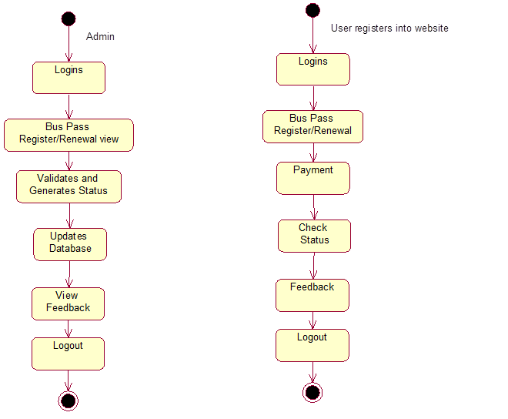

**Fig 4.1.4 :** State chart diagram of Admin and User

A statechart diagram shows a state machine, consisting of states, transitions, events, and activities. Statechart diagrams address the dynamic view of a system. They are especially important in modeling the behavior of an interface, class, or collaboration and emphasize the event-ordered behavior of an object, which is especially useful in modeling reactive systems.

**4.1.5 Class Diagram :**



**Fig 4.1.5 :** Class Diagram

A class diagram shows a set of classes, interfaces, and collaborations and their relationships. These diagrams are the most common diagram found in modeling object-oriented systems. Class diagrams address the static design view of a system.

**4.1.6 Activity Diagram**



An activity diagram is a special kind of a statechart diagram that shows the flow from activity to activity within a system. Activity diagrams address the dynamic view of a system. They are especially important in modeling the function of a system and emphasize the flow of control among objects.

**4.1.7**  **Component Diagram:**



**Fig 4.1.7 :** Component Diagram

**4.1.8**  **Deployment Diagram:**



**Fig 4.1.8 :** Deployment Diagram

A deployment diagram shows the configuration of run-time processing nodes and the components that live on them. Deployment diagrams address the static deployment view of architecture. They are related to component diagrams in that a node typically encloses one or more components

**4.2 Data Base Design**

* **Data Base Tables:**

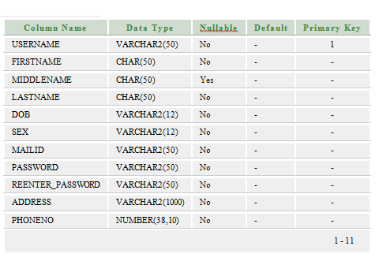

**Fig 4.2.1** : Table For Website Registration

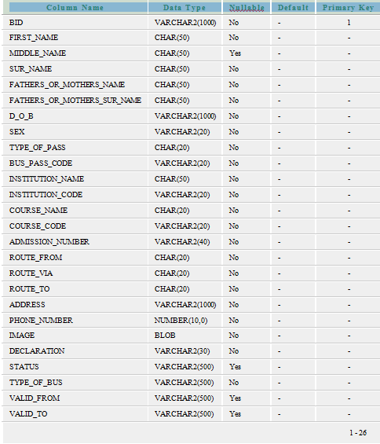

**Fig 4.2.2** : Table For Bus Pass Registration

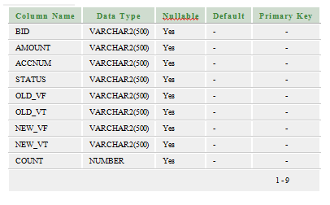

**Fig 4.2.3** : Table For Bus Pass Renewal

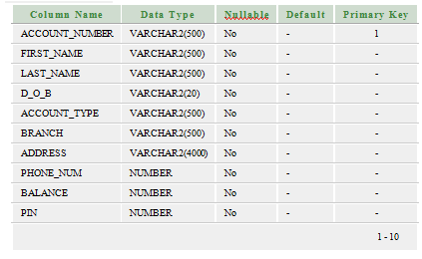

**Fig 4.2.4** : Table For Bank

**5. IMPLEMENTATION**

Implementation is the stage of the project when the theoretical design is turned out into a working system. Thus it can be considered to be the most critical stage in achieving a successful new system and in giving the user, confidence that the new system will work and be effective.

The implementation stage involves careful planning, investigation of the existing system and it’s constraints on implementation, designing of methods to achieve changeover and evaluation of changeover methods.

Implementation is the process of converting a new system design into operation. It is the phase that focuses on user training, site preparation and file conversion for installing a candidate system. The important factor that should be considered here is that the conversion should not disrupt the functioning of the organization.

**5.1 Technology Used:**

Java is a set of several [computer software](http://en.wikipedia.org/wiki/Computer_software) products and specifications from [Oracle Corporation](http://en.wikipedia.org/wiki/Oracle_Corporation) that provides a system for developing [application software](http://en.wikipedia.org/wiki/Application_software) and deploying it in a [cross-platform](http://en.wikipedia.org/wiki/Cross-platform) computing environment.

Java is used in a wide variety of [computing platforms](http://en.wikipedia.org/wiki/Computing_platform) from [embedded devices](http://en.wikipedia.org/wiki/Embedded_device) and[mobile phones](http://en.wikipedia.org/wiki/Mobile_phone) on the low end, to [enterprise servers](http://en.wikipedia.org/wiki/Enterprise_server) and [supercomputers](http://en.wikipedia.org/wiki/Supercomputer) on the high end. While less common, [Java applets](http://en.wikipedia.org/wiki/Java_applet) are sometimes used to provide improved and secure functions while browsing the [World Wide Web](http://en.wikipedia.org/wiki/World_Wide_Web) on [desktop computers](http://en.wikipedia.org/wiki/Desktop_computer).

* **History Of Java**

Java history is interesting to know. Java team members (also known as Green Team), initiated a revolutionary task to develop a language for digital devices such as set-top boxes, televisions etc. For the green team members, it was an advance concept at that time. But, it was suited for internet programming. Later, Java technology as incorporated by Netscape. Currently, Java is used in internet programming, mobile devices, games, e-business solutions etc. There are given the major points that describe the history of java.

1) James Gosling, Mike Sheridan, and Patrick Naught on initiated the Java language project in June 1991. The small team of sun engineers called Green Team.

2) originally designed for small, embedded systems in electronic appliances like set-top boxes.

3) Firstly, it was called "Green talk" by James Gosling and file extension was .gt.

4) After that, it was called Oak and was developed as a part of the Green project.

5) Why Oak? Oak is a symbol of strength and chosen as a national tree of many countries like U.S.A., France, Germany, Romania etc.

6) In 1995, Oak was renamed as "Java" because it was already a trademark by Oak Technologies.

7) Why they choose java name for java language? The team gathered to choose a new name. The suggested words were "dynamic", "revolutionary", "Silk", "jolt", "DNA" etc. They wanted something that reflected the essence of the technology: revolutionary, dynamic, lively, cool, unique, and easy to spell and fun to say. According to James Gosling "Java was one of the top choices along with Silk". Since java was so unique, most of the team members preferred java.

8) Java is an island of Indonesia where first coffee was produced (called java coffee).

9) Notice that Java is just a name not an acronym.

10) Originally developed by James Gosling at Sun Microsystems (which is now a subsidiary of Oracle Corporation) and released in 1995.11) In 1995, Time magazine called Java one of the Ten Best Products of 1995.12) JDK 1.0 released in(January 23, 1996).

* **Features Of Java**

There is given many features of java. They are also known as java buzzwords.

1. Simple
2. Object-Oriented
3. Platform independent
4. Secured
5. Robust
6. Architecture neutral
7. Portable
8. Dynamic
9. Interpreted
10. High Performance
11. Multithreaded
12. Distributed

**Simple :**

According to Sun, Java language is simple because, syntax is based on C++ (so easier for programmers to learn it after C++). removed many confusing and/or rarely-used features e.g., explicit pointers, operator overloading etc. No need to remove unreferenced objects because there is Automatic Garbage Collection in java.

### Object-oriented:

|  |
| --- |
|  |
|  |

Object-oriented means we organize our software as a combination of different types of objects that incorporates both data and behaviour. Object-oriented programming(OOPs) is a methodology that simplify software development and maintenance by providing some rules. Basic concepts of OOPs are:

* Object
* Class
* Inheritance
* Polymorphism
* Abstraction
* Encapsulation

### Platform Independent:

A platform is the hardware or software environment in which a program runs. There are twotypes of platforms software-based and hardware-based. Java provides software-based platform. The Java platform differs from most other platforms in the sense that it's a software-based platform that runs on top of other hardware-based platforms.It has two components:RuntimeEnvironmentAPI(Application Programming Interface)

### Secured: Java is secured because:

* No explicit pointer
* Programs run inside virtual machine sandbox.
* Class loader- adds security by separating the package for the classes of the local file system from those that are imported from network sources.
* Byte code Verifier- checks the code fragments for illegal code that can violate access right to objects. Security Manager- determines what resources a class can access such as reading and writing to the local disk.These security are provided by java language. Some security can also be provided by application developer through SSL,JAAS,cryptography etc.

### Robust:

Robust simply means strong. Java uses strong memory management. There are lack of pointers that avoids security problem. There is automatic garbage collection in java. There is exception handling and type checking mechanism in java. All these points make java robust.

### Architecture-neutral and portable:

There is no implementation dependent features e.g. size of primitive types is set.We may carry the java byte code to any platform.

### High-performance:

Java is faster than traditional interpretation since byte code is "close" to native code still somewhat slower than a compiled language (e.g., C++)

### Distributed:

We can create distributed applications in java. RMI and EJB are used for creating distributed applications. We may access files by calling the methods from any machine on the internet.

**Multi-threaded:** A thread is like a separate program, executing concurrently. We can write Java programs that deal with many tasks at once by defining multiple threads. The main advantage of multi-threading is that it shares the same memory. Threads are important for multi-media, Web applications etc.

* **Java Class Library** :

Java the platform contains around 4,000 classes/interfaces

* Data Structures
* Networking, Files
* Graphical User Interfaces
* Security and Encryption
* Image Processing
* Multimedia authoring/playback And more...
* **Java Framework Architecture:**

The following figure illustrates the architecture of the Silk Performer Java Framework. The figure is divided into three main sections:

* The upper box illustrates supported technologies and test types.
* The middle box illustrates layers of Java Framework code.
* The lower box illustrates available tools.

*Supported Technologies and Test Types* (upper box in figure) In one dimension, the upper box shows some of the supported technologies. The second dimension illustrates the areas of testing in which Java Framework can be used.

*Layers of Java Framework Code* (middle box in figure) The middle box shows the layers of Java Framework code and its connection to various client APIs. The Java Framework API is the “membrane” between BDL code and Java code, symbolized by arrows in the figure. Some of the arrows point in one direction (see “Runtime-to-Java Communication”). Some of the arrows show that communication is possible from Java to the runtime (i.e., Java-to-Runtime communication ).

*Available Tools* (lower box in figure below) In one dimension, the lower box shows Silk Performer tools for generating Java Framework code. The second dimension indicates if code generation is done with the help of Silk Performer tools or 3rd party tools.

* **Web Services**

Web Services provide data and services to other applications. Future applications will access Web Services via standard Web Formats (HTTP,HTML,XML and SOAP), with no need to know how the Web Service itself is implemented. Web Services are main building blocks in the Microsoft .NET programming model.

* **Applications Of Java**
* Since Java has inbuilt networking features so it is widely used for developing network related programs and softwares.Socket programming using JAVA is very simple and efficient and simple and efficient and simple as compared to c.
* It is widely used for creating web applications and it can also generate static HTML content like php and JavaScript so it is used in website designing too.
* In application software development Java is widely used because it is a fully Object Oriented Programming language
* Creating Graphical User Interface (GUI) in Java is very simple and efficient as compared to c and c++.So it is also used in creating GUI for applications.
* That’s all..if you have any more idea or my points seems wrong..then you may write a comment.
* **Challenges Of Java**

Java is unique - it's a mainstream programming language that works like no other. Its rules aren't well understood yet by many application developers. Part of the reason for this is that its capabilities and limitations haven't been fully explored.

As a result, while many of the problems may be similar, recognizing them and knowing what to do when you find them remains challenging, even to experienced Java developers. What follows are just a few of the development issues and what they mean for Java.

***Performance***  
 Performance is a concern of applications written in any language. Most programmers are familiar with common performance issues using a conventional language such as C with a stand-alone or even a client/server application. Such issues often involve improper allocation, deallocation of memory and poor use of system APIs.

These aren't even characteristics of the Java language. For example, relating Java code to how the JVM manages memory is difficult and error-prone. However, it's vital to improve Java performance because its execution model has additional overhead that tends to degrade performance more than native applications do.

In addition to typical performance requirements and issues surrounding traditional stand-alone applications, distributed Java applications must contend with problems surrounding the interactions between components running on different systems. Performance problems may manifest themselves in unexpected ways or appear to be caused by different parts of the code other than the actual problem area. Identifying and locating performance bottlenecks rapidly is a significant challenge in distributed application development.

***Reliability***   
 Enterprise Java applications, especially distributed ones, are often mission-critical in nature: all aspects of the application must work perfectly at all times. Developers and development managers must be able to gauge the reliability of their applications accurately. While the characteristics of the language tend to make Java applications less error-prone, there are still plenty of ways to introduce runtime errors.

With distributed Java applications the reliability equation is even more difficult. It means assessing not only the individual applications but also the components as they interact. Java also makes it possible to write highly threaded applications that make sense in a distributed environment. But using threads means that problems with resource contention and deadlock are much greater.

***Testing***   
 Java applications face the same testing problems as traditional ones. They must be tested as thoroughly as possible before fielded, and developers should have a good idea of the extent of the test coverage before certifying an application. Distributed software systems written in Java, however, are extraordinarily difficult to test and debug. Because components reside on different computers and must work together perfectly for the application to work properly, all components must be tested simultaneously.

***Memory Management***   
 Since JVMs perform all the memory management tasks for applications, understanding the memory usage of the underlying platform and influencing memory allocation and use to affect performance is difficult to do and not intuitive. That's especially true because developers have no easy way of determining the relationship between code and the underlying memory use.

* **Benefits**

1.Simple 2.Platform independent 3.Secure 4.Reliable 5.Multi Tasking6.Dynamic 7.Economical

1) **Simple:**

This particular program is specially designed to be very user-friendly. If compared with other programming languages, Java is easier to write, compile, debug and learn. This is because it uses automatic memory management and garbage collection. unique learners can apply it easily within a short period of time.

2) **Platform-independent:**

The best thing about Java is its ability to go easily from one computer system to another without creating any predicament. “Write once, speed anywhere” best describes Java. It can urge independently at both the source and binary levels. The same program can be race smoothly on different systems. This special feature is extremely well-known to World Wide Web software which needs a lot of flexibility.

3) **Secure:**

If security is your main exertion, Java will be your best choice. It places security as its top priority. Its language, compiler, interpreter and runtime environment are customized with security in mind. Its platform allows users to download unknown code over a network and speed it in a find environment without causing hurt to the systems. The host system will not be infected by virus at all. This capability alone has made the Java platform recent.

4) **Reliable:**

Honestly speaking, it is indeed hard to glimpse for programming languages which are truly robust. However, Java has assign a lot of inconvenience on early checking for possible errors. Java compilers are able to detect many problems at the initial stage of execution. Hence, it is considered the most friendly programming by the developers.

5) **Multiple Tasking:**

Java has the capability to make several tasks simultaneously. Multithreaded programming has been smoothly integrated into it. It works best in visual and network programming. At the same time, its stable standards serve the developers to manufacture multilevel applications with a component based near.

6) **Dynamic:**

Java code is organized in modular object-oriented units. These units are known as classes. They are stored in separate files and are loaded into the Java interpreter only when required. In this state, a program is able to extend itself dynamically by loading which classes it needs to expand its functionality.

7) **Economical:**

How noteworthy do you need to invest on Java programming? It is an launch source. Hence, you don’t need to struggle with heavy license fees annually.

We also used the following in our project

JVM :

A Java virtual machine (JVM) is a [process virtual machine](http://en.wikipedia.org/wiki/Virtual_machine#Process_virtual_machines) that can execute [Java byte code](http://en.wikipedia.org/wiki/Java_bytecode). It is the code execution component of the [Java platform](http://en.wikipedia.org/wiki/Java_platform).

JVM is:

1. **A specification** where working of Java Virtual Machine is specified. But implementation provider is independent to choose the algorithm. Its implementation has been provided by Sun and other companies.
2. **An implementation** Its implementation is known as JRE (Java Runtime Environment).
3. **Runtime Instance** Whenever you write java command on the command prompt to run the java class, and instance of JVM is created.

HTML:

HTML (Hypertext Markup Language) is the set of markup symbols or codes inserted in a file intended for display on a World Wide Web browser page. The markup tells the Web browser how to display a Web page's words and images for the user.

Web documents contain three main sections: the head, title, and body. The head includes the webpage’s identifying information, including the website’s title and important keywords. The viewer sees the site’s title, but any other information is hidden. The site’s title appears in the browser’s tab and is what appears when a user tries to bookmark a site. The body section is the main portion of the webpage visible to the viewer, including the text and graphics. HTML tags are also used in two additional ways that are not visible to the viewer: as meta tags and comments. Meta tags indicate keywords associated with the webpage to search engines. Comments are intended as explanation or additional information for other writers or readers of HTML code.

JSP:

Java Server Pages (JSP) is a technology that helps [software developers](http://en.wikipedia.org/wiki/Software_developer) create pages based on [HTML](http://en.wikipedia.org/wiki/HTML), [XML](http://en.wikipedia.org/wiki/XML), or other document types.

Java Server Page (JSP) is a technology for controlling the content or appearance of Web pages through the use of servlets, small programs that are specified in the Web page and run on the Web server to modify the Web page before it is sent to the user who requested it.

JDBC:

JDBC is a Java-based data access technology (Java Standard Edition platform) from [Oracle Corporation](http://en.wikipedia.org/wiki/Oracle_Corporation). This technology is an [API](http://en.wikipedia.org/wiki/Application_programming_interface) for the [Java programming language](http://en.wikipedia.org/wiki/Java_(programming_language)) that defines how a client may access a [database](http://en.wikipedia.org/wiki/Database).

JDK:

The Java Development Kit (JDK) is a software development environment used for developing Java applications and applets. It includes the Java Runtime Environment (JRE), an interpreter/loader (java), a compiler (javac), an archiver (jar), a documentation generator (javadoc) and other tools needed in Java development

Java Development Kit (JDK) The JDK is a superset of the JRE, and contains everything that is in the JRE, plus tools such as the compilers and debuggers necessary for developing applets and applications.

CSS:

CSS is the language for describing the presentation of Web pages, including colors, layout, and fonts. It allows one to adapt the presentation to different types of devices, such as large screens, small screens, or printers. CSS is independent of HTML and can be used with any XML-based markup language. The separation of HTML from CSS makes it easier to maintain sites, share style sheets across pages, and tailor pages to different environments. This is referred to as the separation of structure (or: content) from presentation*.*

Use CSS to define styles for your documents, including the design, layout and variations in display for different devices and screen sizes. You can place your CSS in the <head> of a document with an embedded style sheet, or attach a separate file that defines your styles with an external style sheet. To link an external style sheet to your document, you'll simply add a link to the style sheet in the <head> of the document.

**5.2 Introduction To Oracle 10G:**

Oracle Database 10*g* was the first database designed for grid computing, the most flexible and cost-effective way to manage enterprise information. It cut costs of management while providing the highest possible quality of service.

Oracle Database 10g Express Edition (Oracle Database XE) is an entry-level, small-footprint database based on the Oracle Database 10g Release 2 code base that's free to develop, deploy, and distribute; fast to download; and simple to administer.

An Oracle **database** is a collection of data treated as a unit. The purpose of a database is to store and retrieve related information. A database server is the key to solving the problems of information management. In general, a **server** reliably manages a large amount of data in a multiuser environment so that many users can concurrently access the same data. All this is accomplished while delivering high performance. A database server also prevents unauthorized access and provides efficient solutions for failure recovery.

The database has **logical structures** and **physical structures**. Because the physical and logical structures are separate, the physical storage of data can be managed without affecting the access to logical storage structures.

Oracle Database 10g marks the latest release by a company that has experienced a meteoric rise to success over the past 25-plus years. They have been grossing many billions of dollars annually for many years, vending a suite of solutions powered by their flagship product the Oracle database. It has gone through many changes in names v6, Oracle7, Oracle8i, Oracle9i, and now Oracle 10g. Regardless of what it is called, the Oracle server has been catapulted to the forefront of our Internet-savvy society, playing a role as the primary data server on a web site in your neighborhood. This book is your introduction to the Oracle Database 10g technology. It is the start of your journey a quick start to a complex and popular technology.

Oracle Database 10g is the culmination of thousands upon thousands of person hours building an infrastructure to deliver data to a hungry, worldwide community, just as electricity is delivered to a three-prong outlet near you. Larry Ellison, CEO of Oracle Corporation, is a visionary steering Oracle's product set in directions unheard of before. You cannot read any public relations or technical material from Oracle Corporation without hearing that four letter word grid. With grid computing, the industry envisions a computational grid where machines all the way from the Intel-based server to the high-end servers from HP, IBM, and Sun are interlaced with one another is a massively scalable and sharable environment.

**5.2.1 Oracle Architecture**

The Database:

The Oracle database has a logical layer and a physical layer. The physical layer consists of the files that reside on the disk; the components of the logical layer map the data to these physical components.  
  
The Physical Layer:

The physical layer of the database consists of three types of files:   
One or more data files--Data files store the information contained in the database. You can have as few as one data file or as many as hundreds of data files. The information for a single table can span many data files or many tables can share a set of data files. Spreading table spaces over many data files can have a significant positive effect on performance. The number of data files that can be configured is limited by the Oracle parameter MAXDATAFILES.

Two or more redo log files--Redo log files hold information used for recovery in the event of a system failure. Redo log files, known as the redo log, store a log of all changes made to the database. This information is used in the event of a system failure to reapply changes that have been made and committed but that might not have been made to the datafiles. The redo log files must perform well and be protected against hardware failures (through software or hardware fault tolerance). If redo log information is lost, you cannot recover the system.   
One or more control files--Control files contain information used to start an instance, such as the location of data files and redo log files; Oracle needs this information to start the database instance. Control files must be protected. Oracle provides a mechanism for storing multiple copies of control files.   
  
The Logical Layer:

The logical layer of the database consists of the following elements:   
One or more table spaces.   
 The database schema, which consists of items such as tables, clusters, indexes, views, stored procedures, database triggers, sequences, and so on.

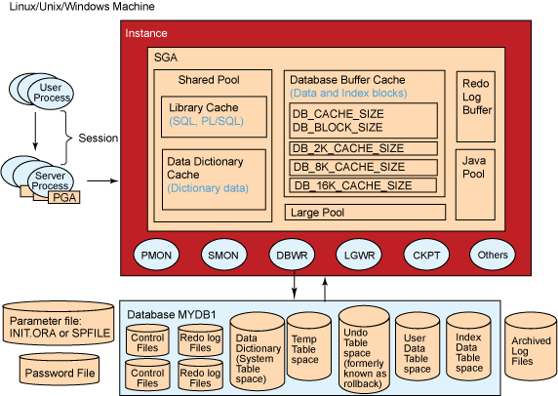

**Fig 5.2.1:** Oracle Architecture

**5.2.2 Loading Data**

You have an sql file manager that contains all the necessary commands and insert statements to load into the Oracle Database 10g Express Edition database. The script that will be loaded is called http://software.ucv.ro/~aion/pbd.html. This data contains information about each employee and about that employee's department.

**Steps:**

1. Log in with your account

2. Select SQL>SQL Scripts> Upload

3. Select the file you want to upload and click Upload

4. Select the file icon and click Run twice to execute the script

5. Review the results of the execution

6. Browse the database objects and data

**6. TESTING**

**6.1 Introduction:**

Software testing is a critical element of software quality assurance and represents the ultimate review of specification, design and coding. In fact, testing is the one step in the software engineering process that could be viewed as destructive rather than constructive.

A strategy for software testing integrates software test case design methods into a well-planned series of steps that results in the successful construction of software. Testing is the ser of activities that can be planned in advanced and conducted simultaneously. The underlying motivation of program testing to affirm software quality with methods that can economically and effectively is applied to both strategic to both large and small-scale systems.

The following are the testing objectives:

* Testing is a process executing a program with the intent of finding an error.
* A good test has a high probability of finding an as yet undiscovered error.
* A successful test is one that uncovers an as yet undiscovered error.

**6.2 Design Of Test Cases And Scenarios:**

The objective is to learn tests that systematically uncover different classes of errors and do so with a minimum amount of time and effort. Testing cannot show the absence of defects, it can only show that software defects are present.

**Unit Testing:**

* Interface
* Number of input characters should be equal to number of arguments.
* Parameters and arguments attributes must match.
* Parameters passed should be in correct order.
* Global variable definitions consistent across module.
* If module does I/O.
* File attribute should be correct.
* Open/Close statements must be correct.
* Format specifications should match I/O statements.
* Buffer size should match record size.
* Files should be opened before use.
* End of file condition should be handled.
* I/O errors should be handled.
* Any textual errors in output information must be checked.
* Local Data Structures (common source of errors).
* Improper or inconsistent typing.
* Erroneous initializing or default values.
* Incorrect variable names.
* Inconsistent data types.
* Overflow, underflow, address exception.
* Boundary conditions and independent paths.
* Error handling.
* Error description unintelligible.
* Error noted does not correspond to error encountered.
* Exception condition processing incorrect.

**Integration Testing:**

Module integrated by moving down the program design hierarchy. Can use depth firs**t** or breadth first top down integration verifies major control and decision points early in design process. Top-level structure tested most. Depth first implementation allows a complete function to be implemented, tested and demonstrated and does depth first implementation of critical function early. Top down integration forced (to some extend) by some development tools in program with graphical user interfaces. Begin construction and testing with atomic modules (lowest level modules).

Bottom up integration testing as its name implies being construction and testing with atomic modules. Because modules are integrated from the bottom up, processing required for module subordinate to a given level is always available and the need for stubs is eliminated.

**Top-Down Integration:**

Top-Down Integration testing is an incremental approach to construction of program structure. Modules are integrated by moving download through the computer hierarchy, beginning with the main control module.

The Top-Down integration process is performed in the following five steps:

* The main control module is used as a test driver and subs are substituted for all the components directly subordinate to the main control module.
* Depending on the integration approach selected, subordinate stubs are replaced one at a time with actual components.
* Tests are conducted as each component is integrated.
* On completion of each of test, another stub is replaced with the real components.
* Regression testing may be conducted to ensure that new errors have not been introduced.

**Bottom-Up Integration:**

Bottom-Up Integration testing as its name implies, being construction as testing with atomic modules because components are integrated from the bottom up, processing required for components subordinate to a given level is always available and for stuns is eliminated.

* The Bottom-Up Integration is performed in the following four steps:
* Low-Level components are combined into clusters that perform a specific software stub function.
* Driver is written to coordinate test case input and output.
* The cluster is tested.

**Test Cases And Scenarios:**

A TEST Plan is a systematic approach to test a system as a machine or software. The plane typically contains a detailed understanding of what the eventual work flow will be UINT LEVEL plan for JOB ad.

**Test Report and Results:**

|  |  |
| --- | --- |
| TEST REPORT NO | 1 |
| PROJECT NAME | Integrated Ticket system |
| MODULE NAME | STUDENT REGISTRATION |
| FORM NAME | REGISTRATION |
| UNIT NAME | USER NAME & DETAILS OF STUDENTS |
| TEST RESULTS | ON CLICKING SUBMIT BUTTON AFTER PROVIDING YOUR PARTICULAR ACCOUNT WILL BE CREATED AND YOU CAN LOGIN TO THE SITE. |

**Test Plan 1:**

Project Name: Integrated Ticket system

Module Name: STUDENT Module.

Unit Name: User Name.

Test Result: The User Name Textbox is tested and verified.

Test Plan (Unit Module/Test Integration)

Test plan Integrated Ticket system

Unit ID: LOGIN.

Test Case ID: Login Page.

Test Type: Unit Case.

Form Name: LOGIN.

Base Table: Registration.

**Purpose:**

Registration table is used for store the details of registered members details and along with their Username and Password. By using these details the administrator can perform the operations.

**Test Case Description:**

* **Test Data**

|  |  |  |
| --- | --- | --- |
| SNO | INPUT SPECIFICATION | EXPECTED RESULT/OUTPUT |
| 1. | Column Name: User Id  Valid Input: If the User id valid along with password then the form will be navigated to allotted page.  Invalid Input: If the User Name should be reentered. | Valid Output: If the User Name and Password are correct then form navigation to home page.  Invalid Output: If the User Name is incorrect error message is displayed as “User Invalid” and it will ask for User ID & Password. |

**TEST COMPLETION CRITERIA:**

When expected results match the actual results performing the test, the test is considered to be completed.

**Validation Testing:**

Validation succeeds when system functions in a manner that can be reasonably by the end-user. This is achieved through a series of black-test that demonstrate with requirements.

There are two tests for system conduction for the system validation:

* **Alpha Testing:**

A customer conducts it at the developer’s site. The software is used in a nature setting with the developer “looking over the shoulder” of the user and recording errors and usage problems.

* **Beta Testing:**

This test is conducted at one or more users sited by the end user of the software. Here the developer generally not presents. Therefore, the beta test in a “line” application of the software in an environment that can’t be controlled by the developer.

**System Testing:**

Once the software product is developed, it is thoroughly tested and it is delivered to the users. Now, it has to be tested by developing it on the system i.e., to what the given software is comfortable to the environment. The software engineer should consider these issues during early stages of software development to release himself from the problems which are encountered after completion of the software. Hence, the tests conducted to ensure that the software is comfortable with the system, where it is deployed is referred as “System Testing”.

* **Recovery Testing**

It is often a nature fact that certain errors may corrupt the system or may make the system not to function properly to a stipulated period of time. Hence, recovery testing is the process which given software id exposed to failures and it is tested to see its recovery capabilities.

Usually the recovery can be of two types:

* Automatic through human intervention.
* Recovery through human intervention.

During automatic recovery the software itself recovered. Sometimes requires certain addition support like system restart, reutilization, data recovery, etc., for tis normal execution when the system requires human intervention in order to recover from such recovery is referred as recovery through human intervention. Here, mean-time-to-repair is a value which is calculated to ensure that the software gets recovered within acceptable span of time.

* **Security testing:**

Security plays a major role especially in that software. Which are made to deal with highly confidence data. For these systems, often several hackers try their to break the security of the system and acquire the confidential data for their foolish requirements. Hence, for these systems, security measures should be given vital importance. For this purpose, the testers themselves disguise into hackers and perform series of attempts to breaks the security of the given software can be truly judged.

* **Stress Testing**

Stress testing is usually performance to check the limits of the system i.e., to what extend the system can resists the abnormal conditions. Hence, the system is tested by providing abnormal resources in different proportions. During stress testing a system can be.

* Providing the excess values of data in different proportions to check its memory management capabilities i.e., how efficiently the system manages the data which is more than its capability.
* Exposed to certain programs demanding large memory and resources not available with the current system.
* Providing too many interrupts during a specific period of time.
* Providing with too many inputs through it can survive only few input
* **Performance testing**

Performance testing is essential to ensure the given software performance to the execution when it is implemented on the system. Hence, in this case it is only the software considered but also the hardware in which it is deployed. Here, the performance testing is combined with the stress testing cases to check the internal aspects such as resources utilization and various other instances.

|  |  |  |  |  |
| --- | --- | --- | --- | --- |
| Test Case Number and Name | Test Execution Steps | Expected Result | Test Result | Type of Test |
| Check Username  And Password | Run application and click  Login button | If the User Name and Password are correct then navigate user from home page. | PASS | Functional Testing |
| Check Payment is done or not | Run application  and click submit button in Bus Pass Registration Page | Your payment is done successfully | PASS | Functional testing |
| Check Renewal is done or not | Run application  And check status | Your Status is shown | PASS | Functional testing |
| Check Feedback is submitted or not | Run application  Click on Submit button | Your feedback is submitted successfully | PASS | Functional testing |
| Check whether the values are updated or not | Admin will view by logging into his/her website | Updated successfully | PASS | Functional testing |

**Fig 6.2.1:** Test Cases

**6.3 Screen Shots**

**User Manual**

The Operation of this manual is customers and admin how to going to be used in this document. For customer we are showing separate web pages and for admin am showing different pages.

**User Manual Document Format**

**Introduction**

Customer can register first after register he can login. Here for bluewave contain the student, employee’s passengers with disability and senior citizens peoples can use this system.

**Hardware Configuration**

I was installed this web site into my machine, the Hardware configuration am writing fallows the following are the minimum hardware compatibility is required.

* System : Pentium IV 2.4 GHz.
* Hard Disk : 320 GB.
* Monitor : 15 VGA Colour.
* Mouse : Logitech.
* Ram : 512 Mb.

**SOFTWARE REQUIREMENTS:**

* Operating system : Windows 7.
* Coding Language : JAVA/J2EE
* IDE : Netbeans 7.2
* Database : MYSQL
* Web Server : Tomcat 7.0
* WEB Browser : Google Chrome
* Documentation : Rational Rose

Screens Dumps

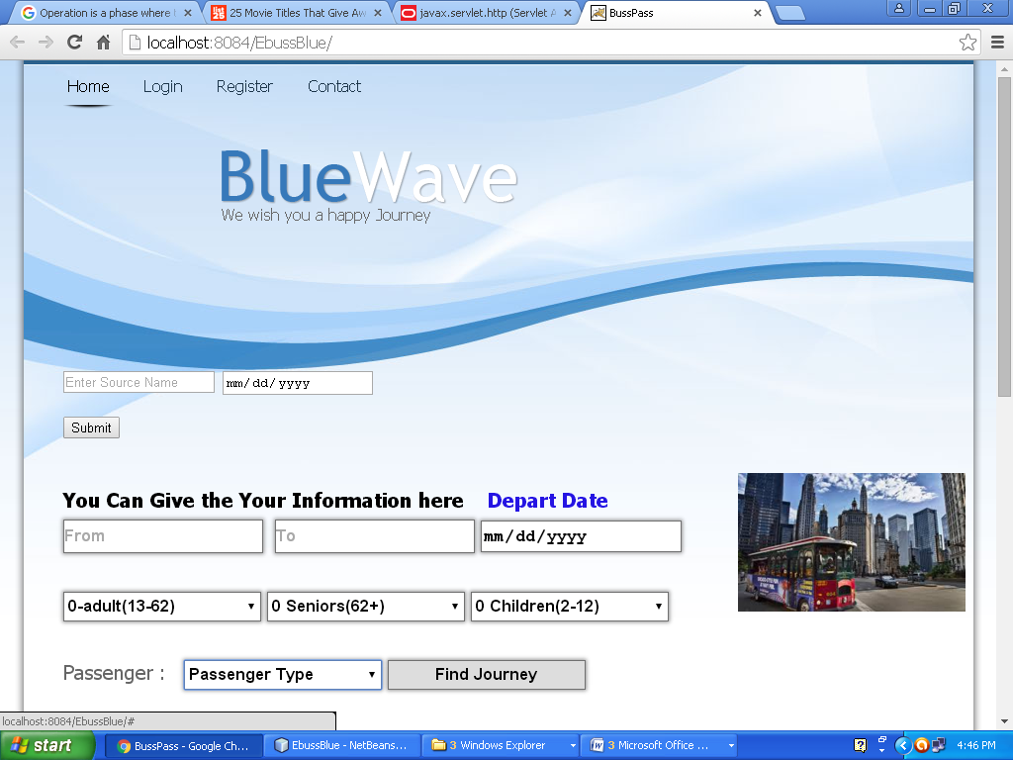

Homepage of the Bluewave

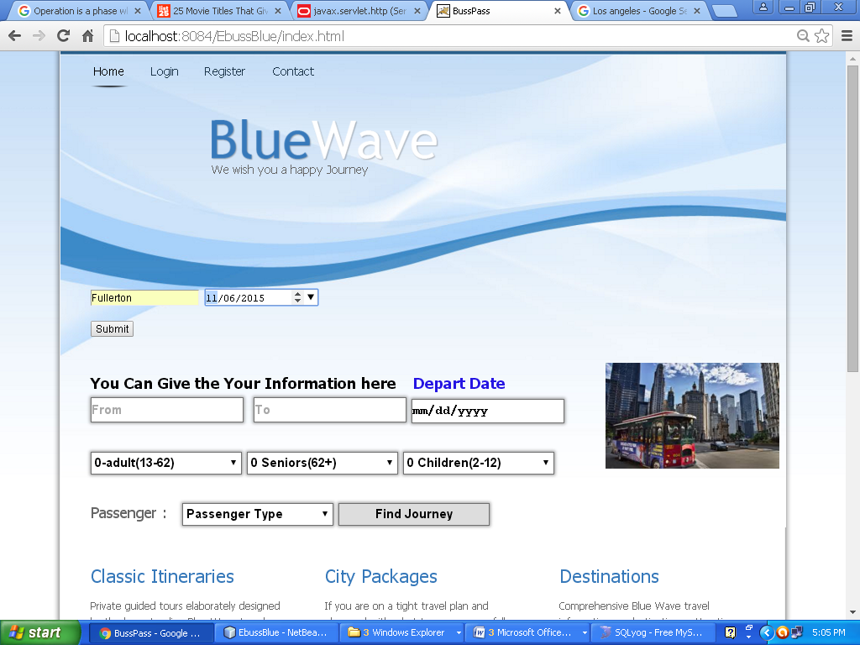

Finding Available busses or trains from the given Stop name

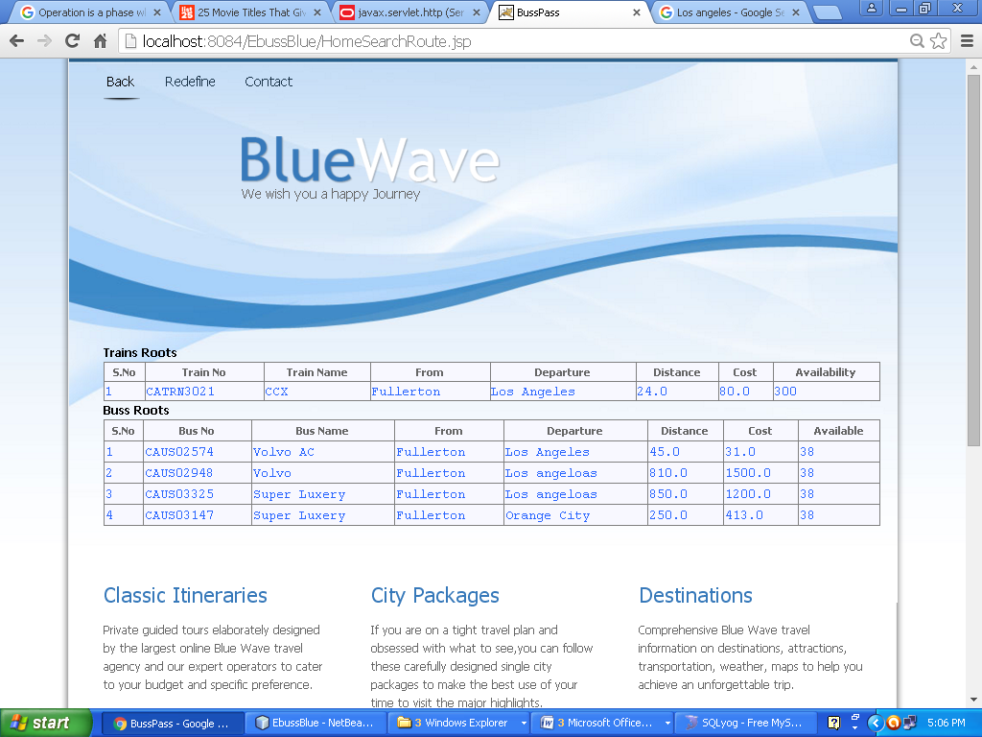

View The bus and Trains and fare

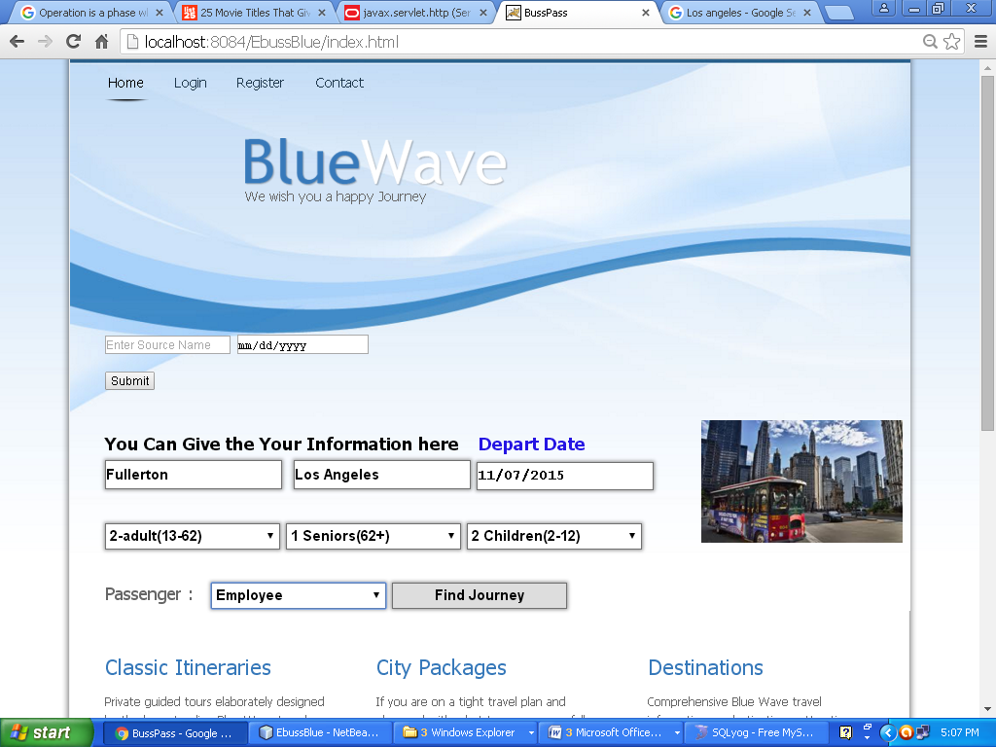

Planning Journey without Login

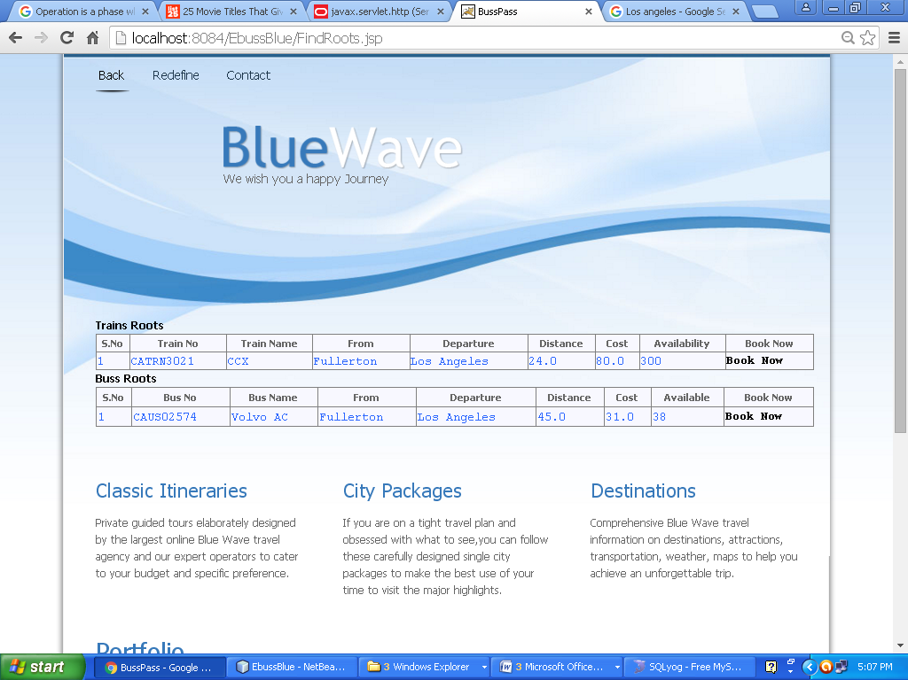

Showing available data

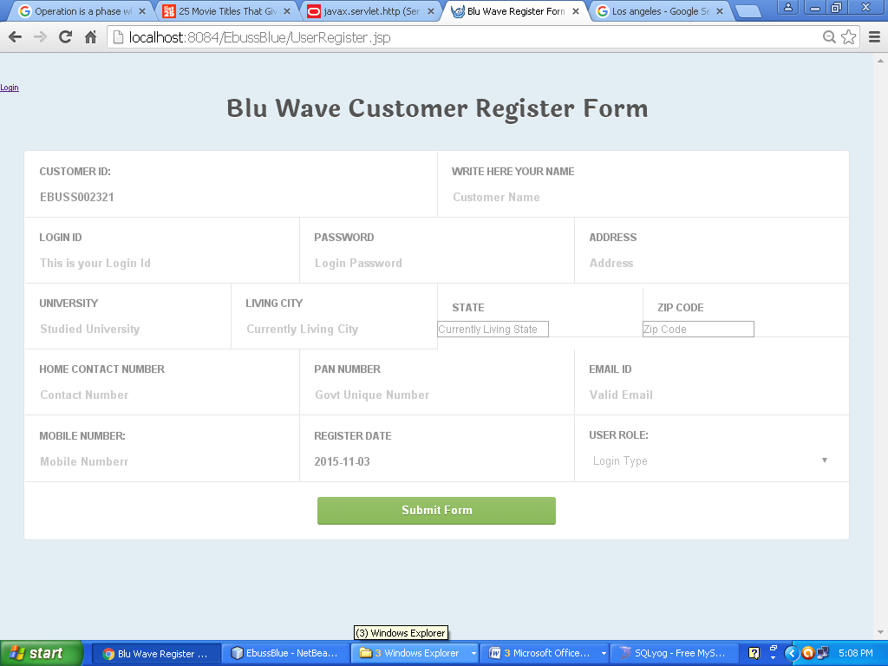

Registration Form of the Customer

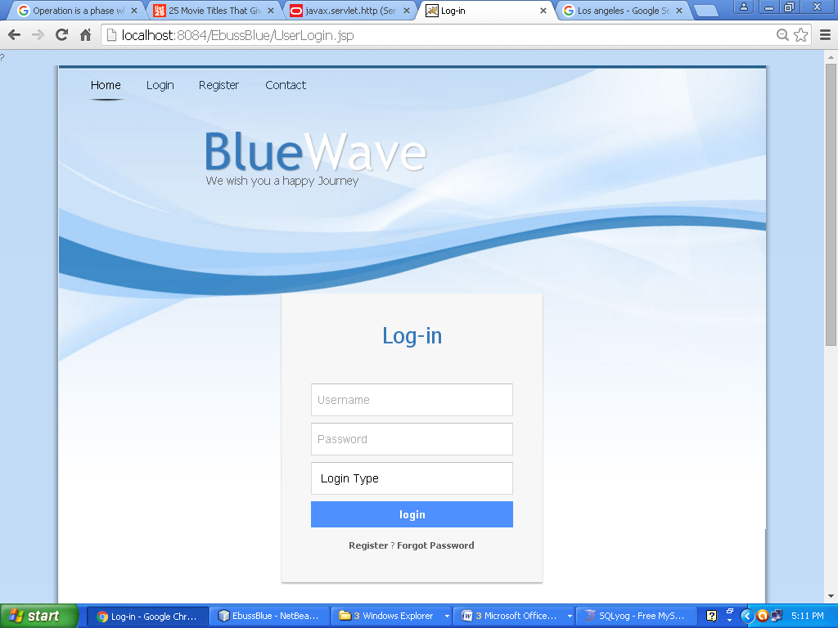

Customer Login page

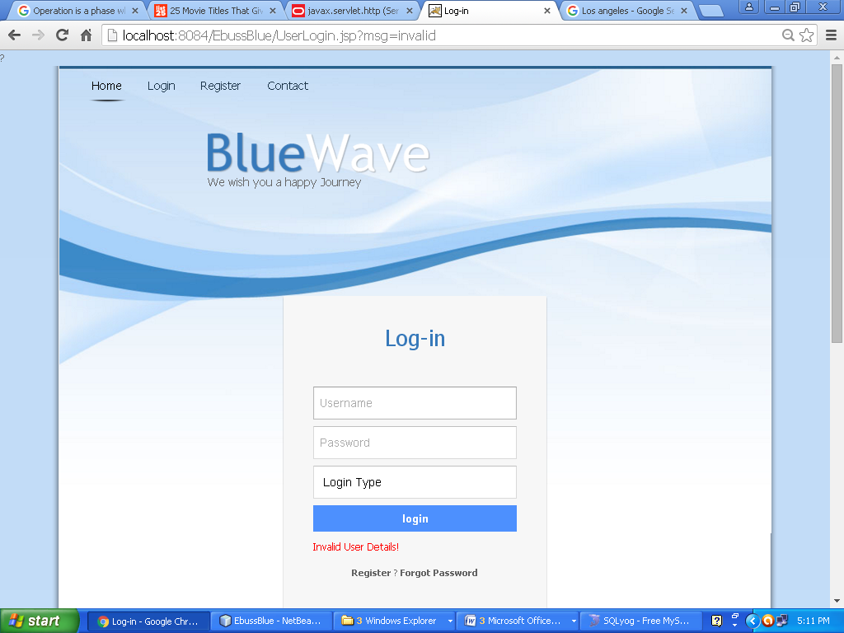

Login failed

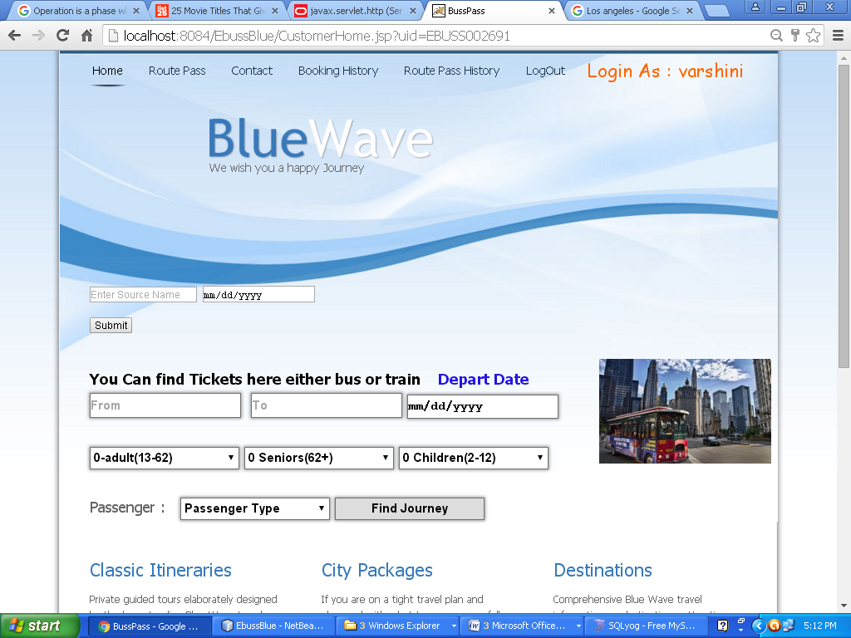

Customer Home Page

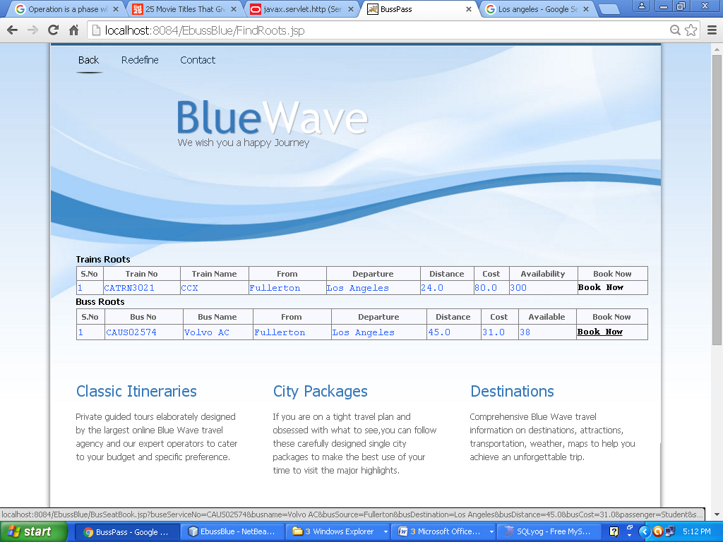

Logged Customer Book

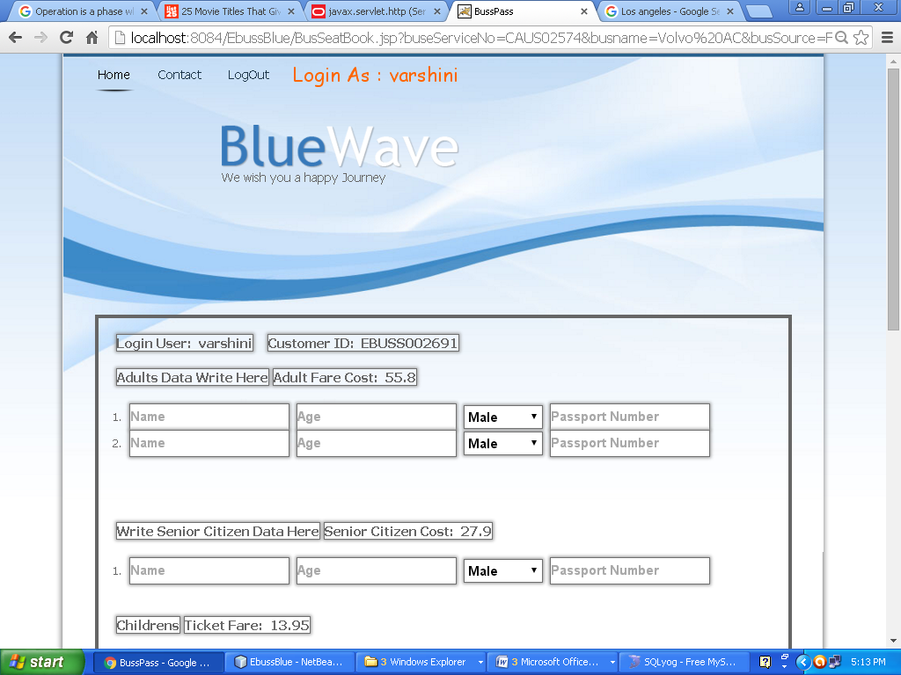

Filling the Traveling Persons Names

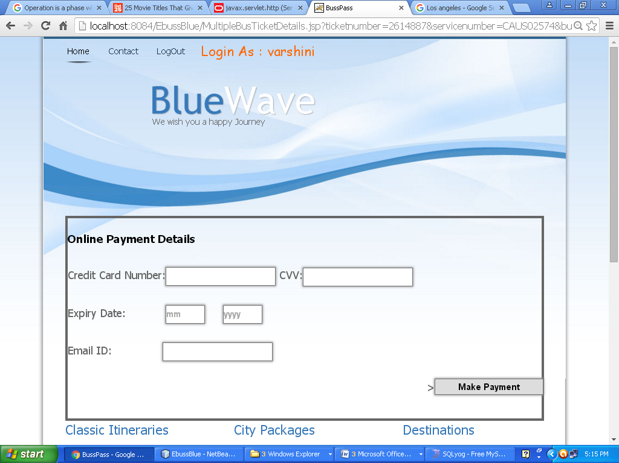

Payment Gateway

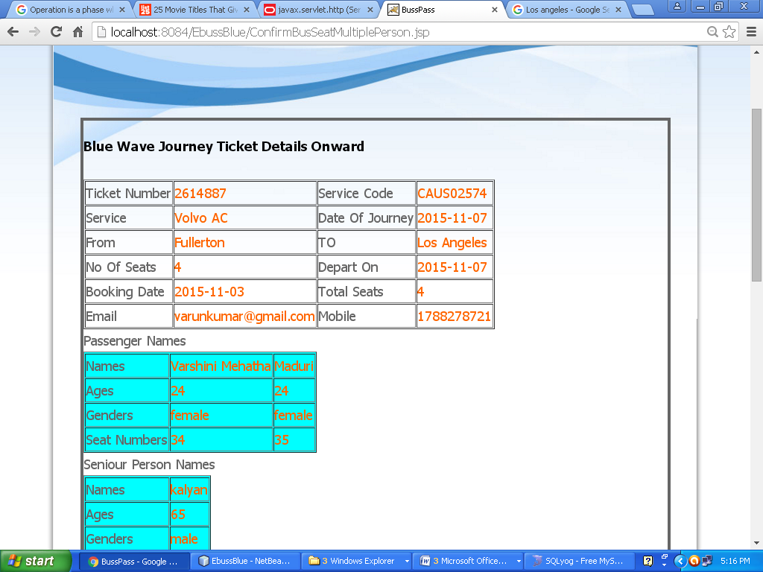

Final Ticket For The Customer

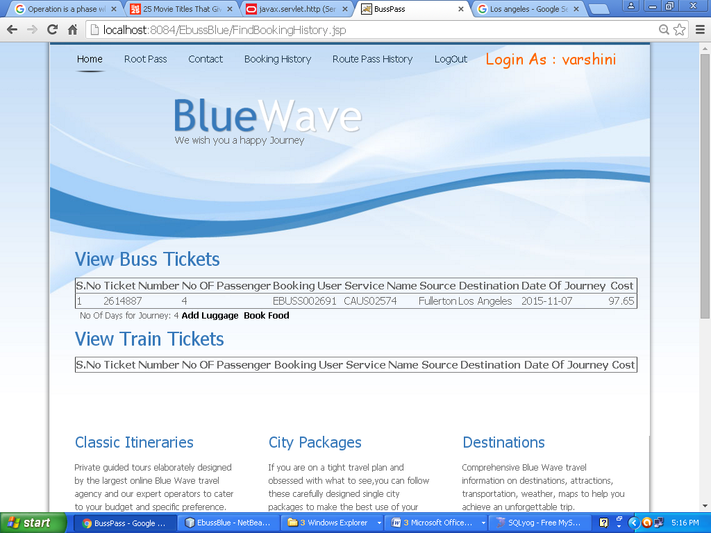

Adding Luggage

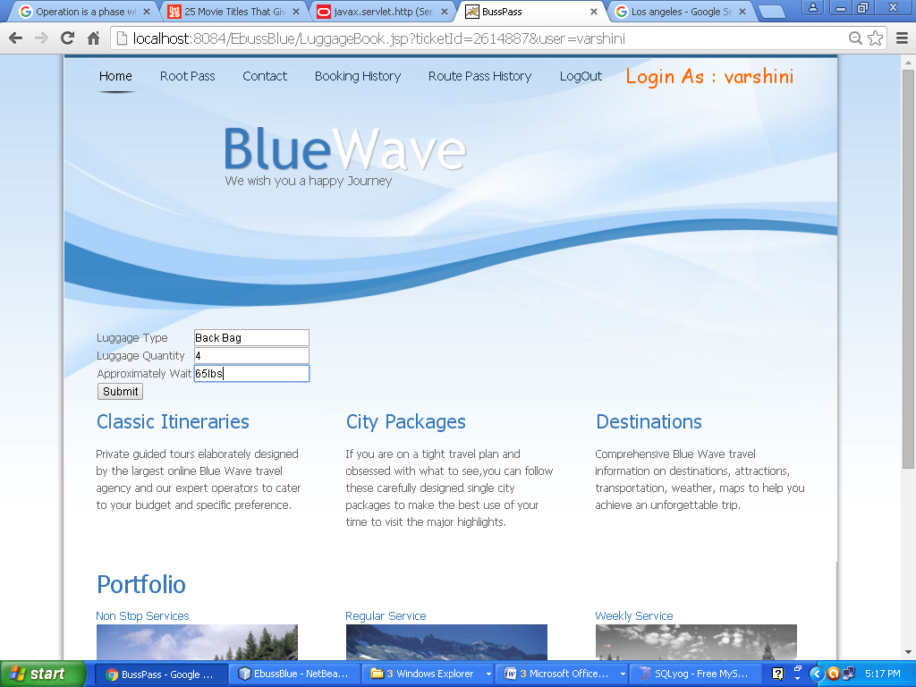

Adding Luggage Info

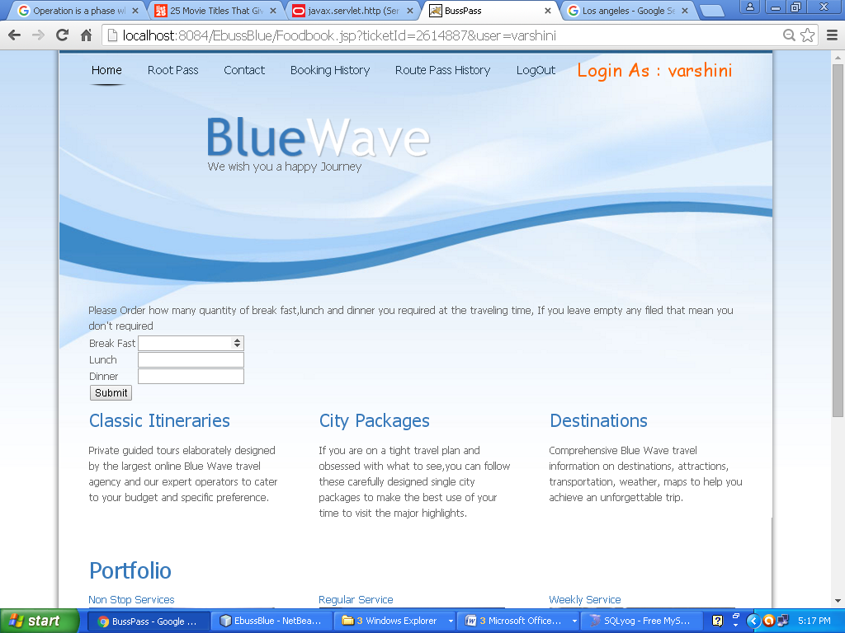

Adding Food Data

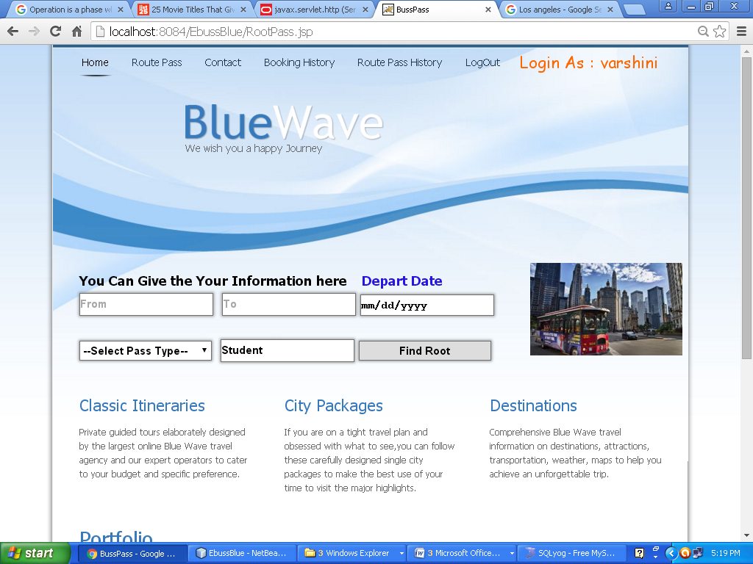

Finding Route Pass

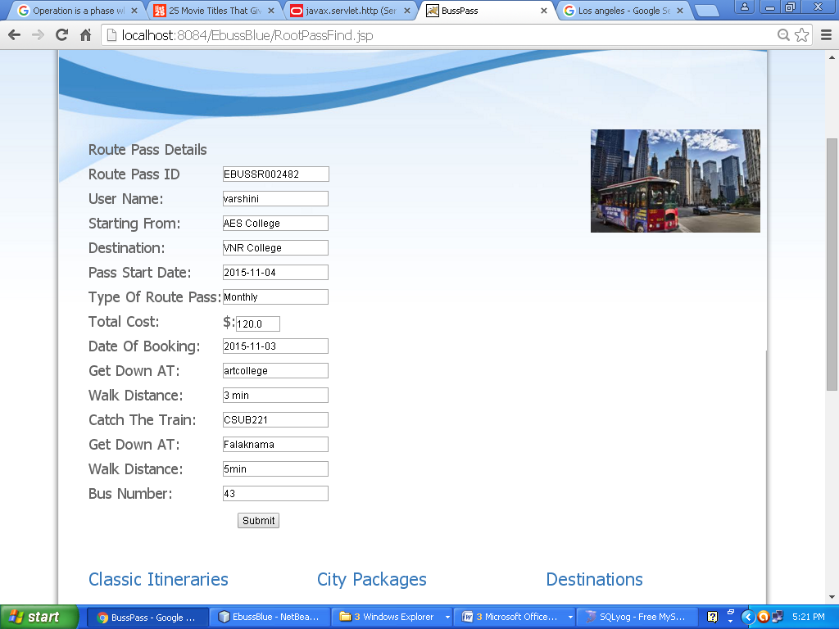

Routes pass for the customer

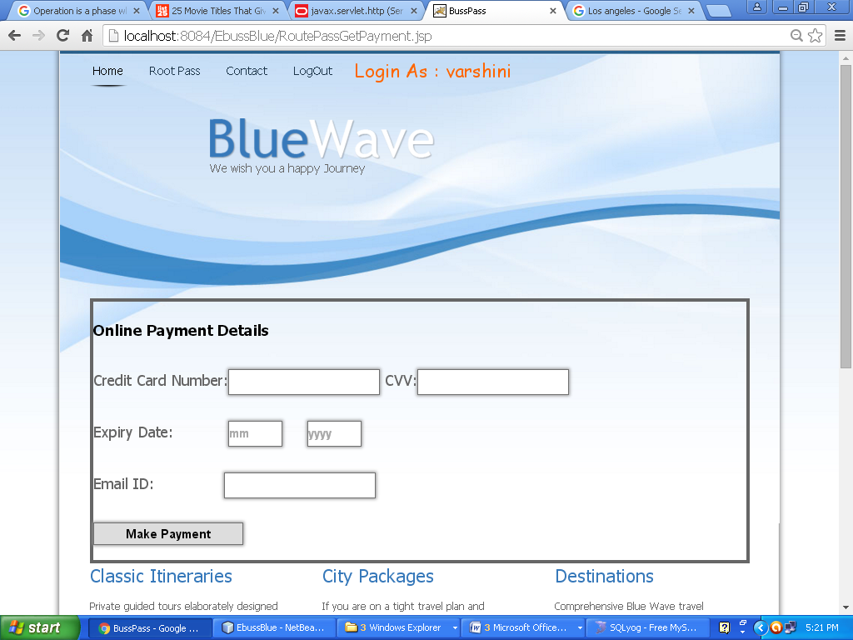

Payment gateway for Customer

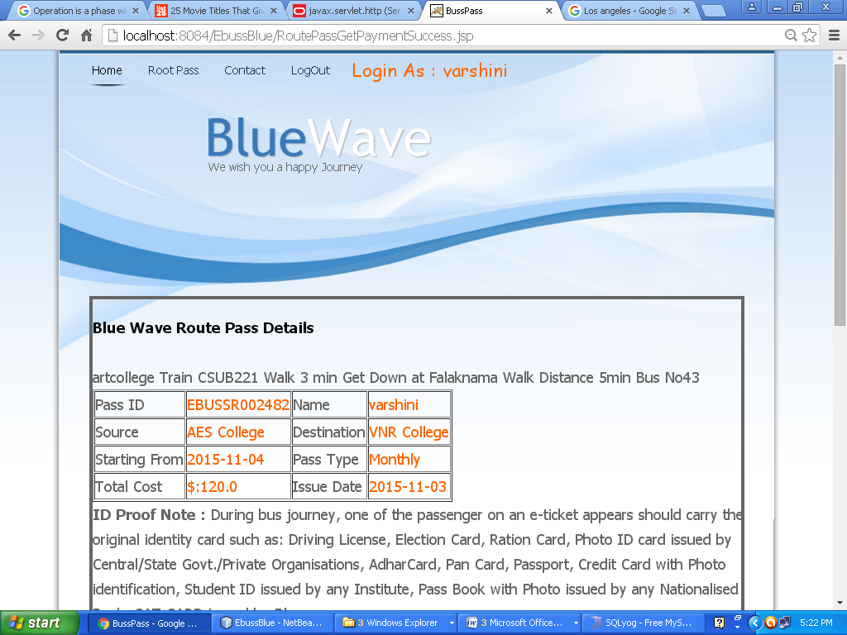

Route Pass final ID

Here Customer has to remember the Pass ID

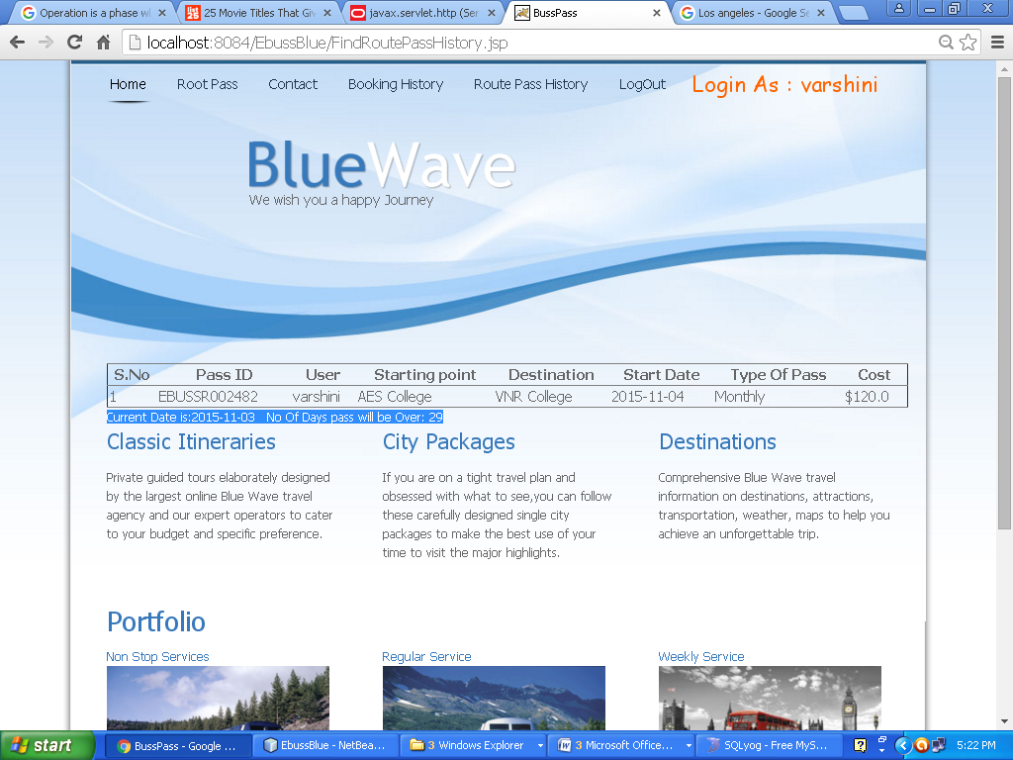

Route Pass Expires in Some days

Admin Login Page

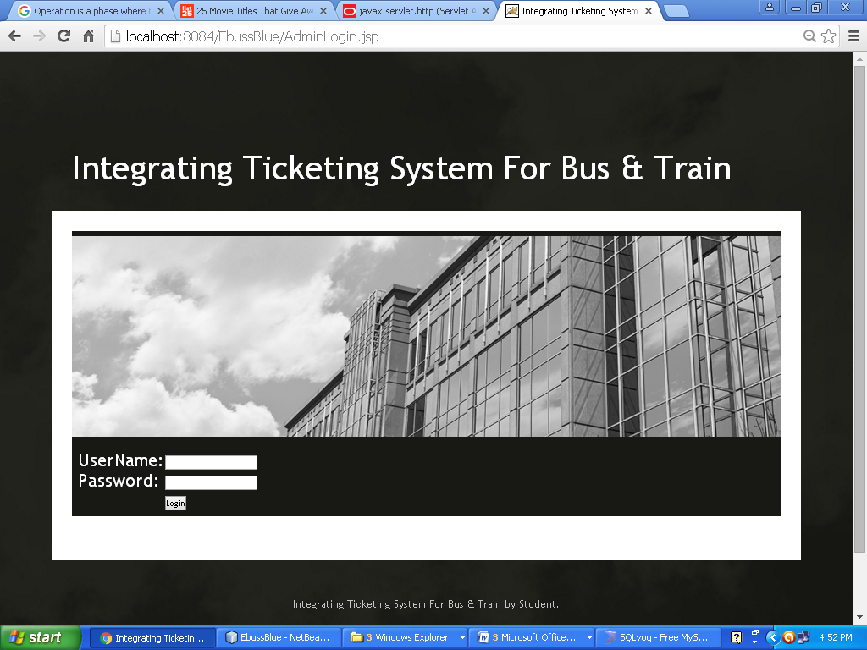

Admin Login page

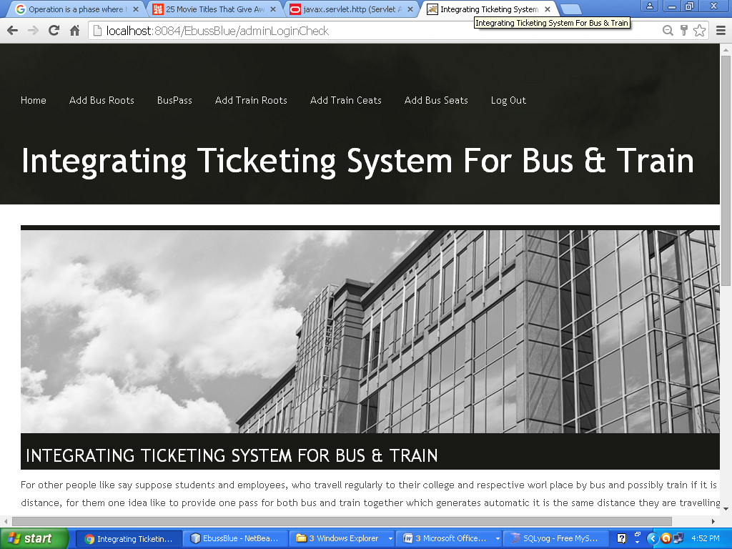

Admin Homepage

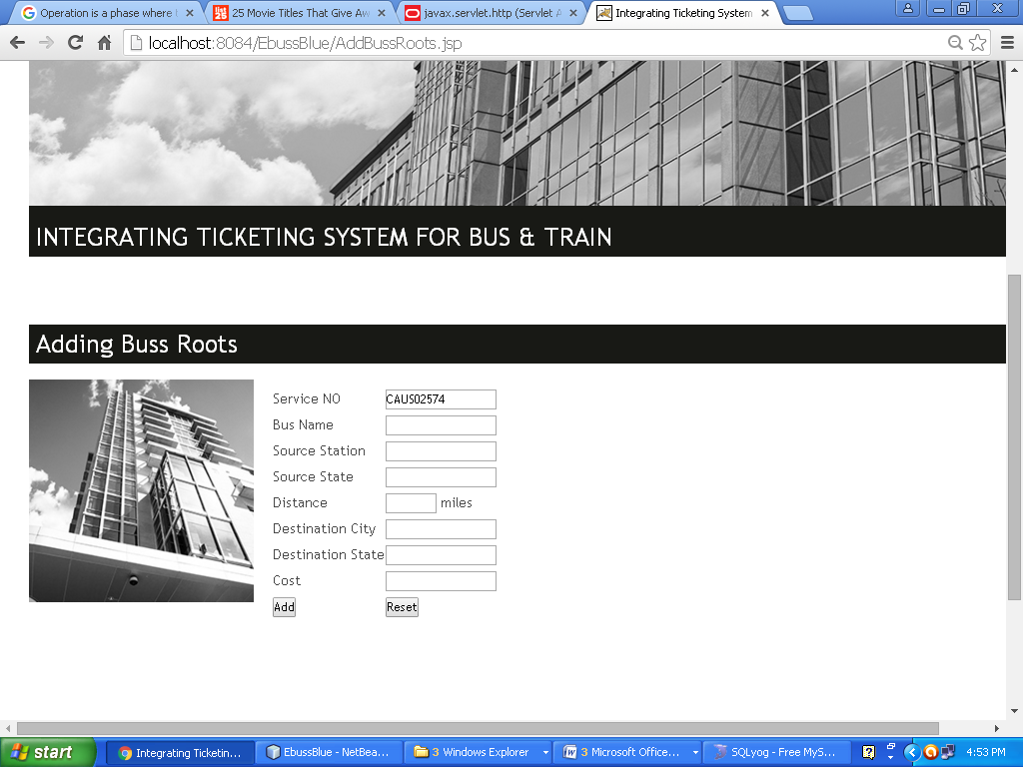

Adding Bus route by Admin

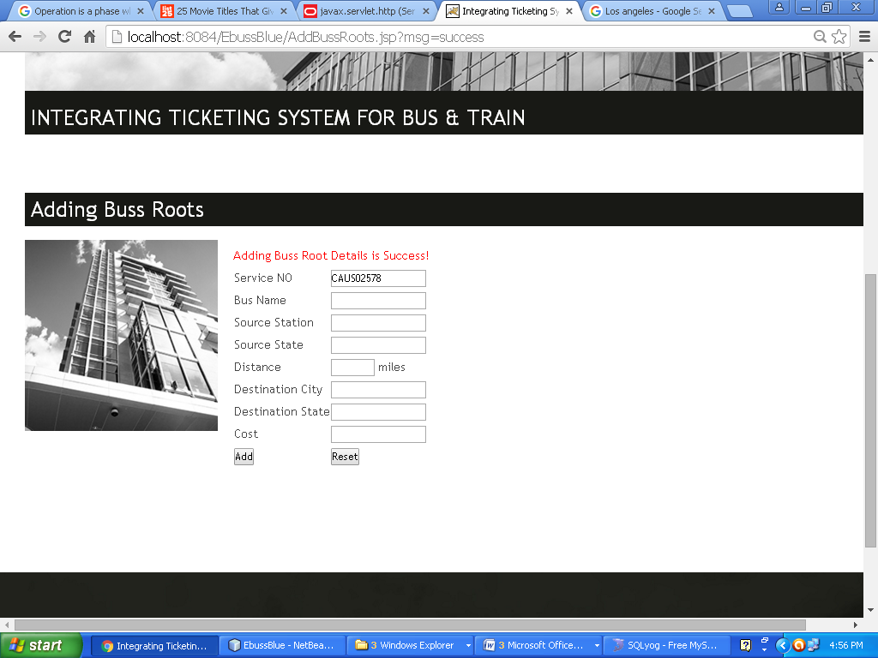

Buss Route Added By Admin Success

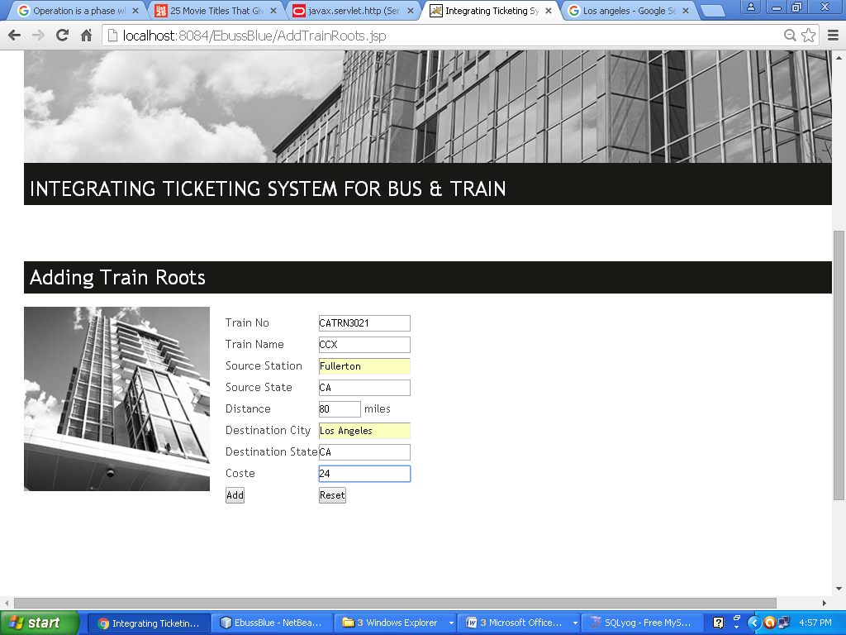

Train Route Adding by Admin

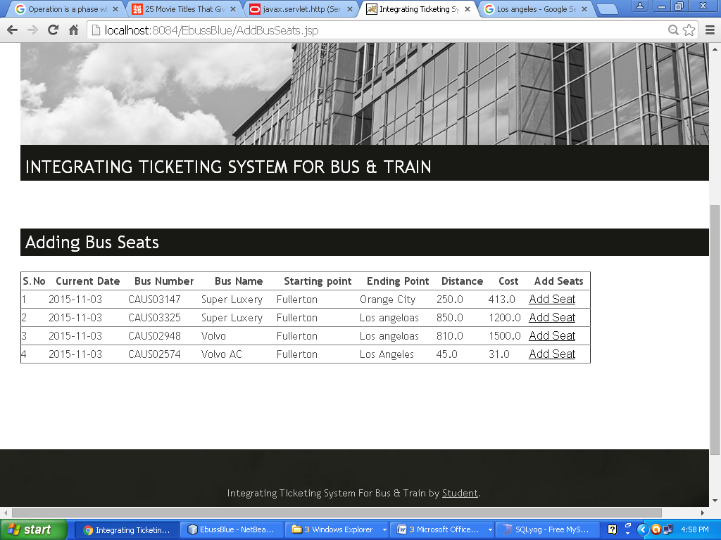

Add for Seats in bus here Admin can click the add seats to the particular bus route in that buss initially the 38 seats will be added for next 60 days.

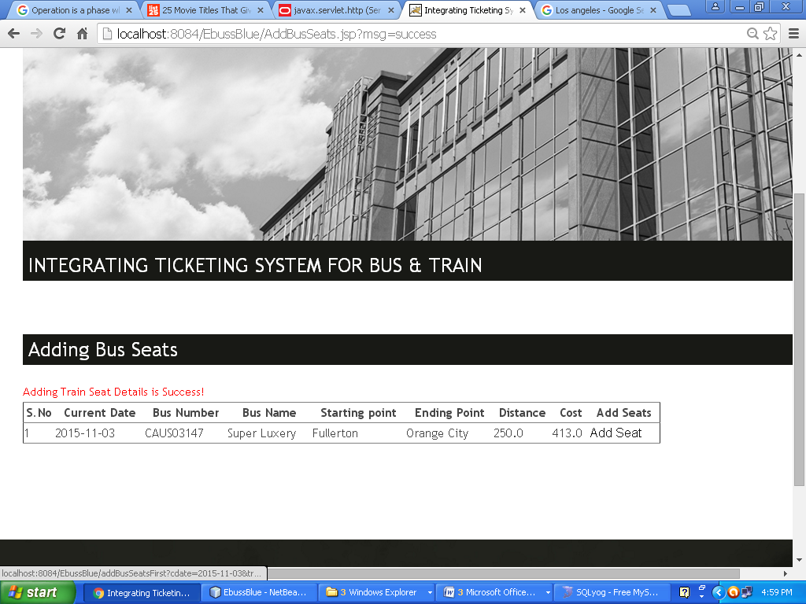

Added Bus Seat Success

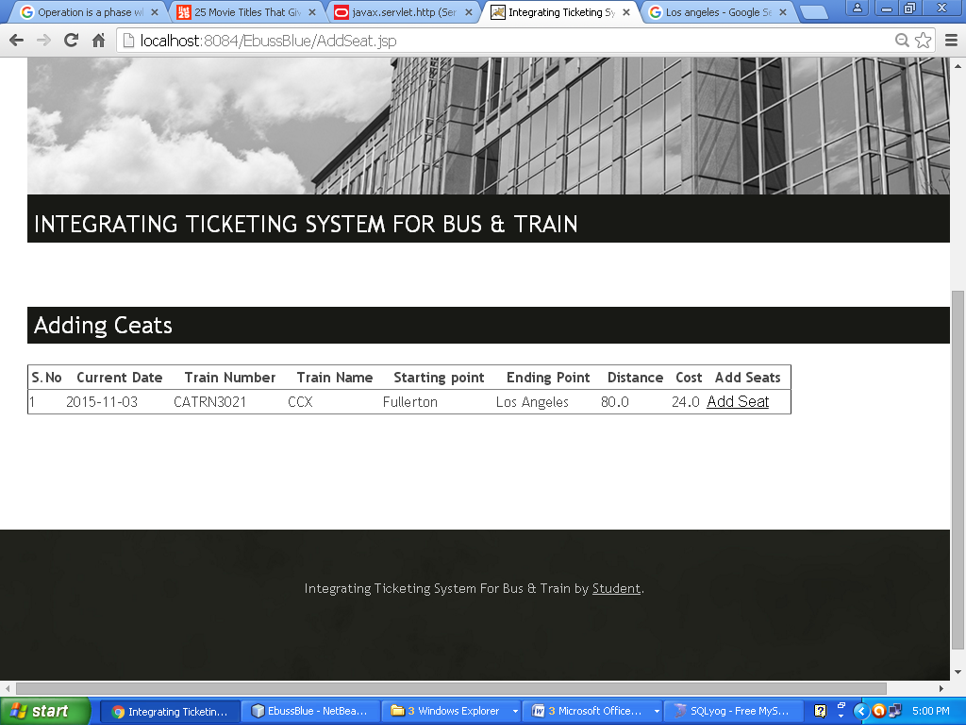

Adding Train Seats

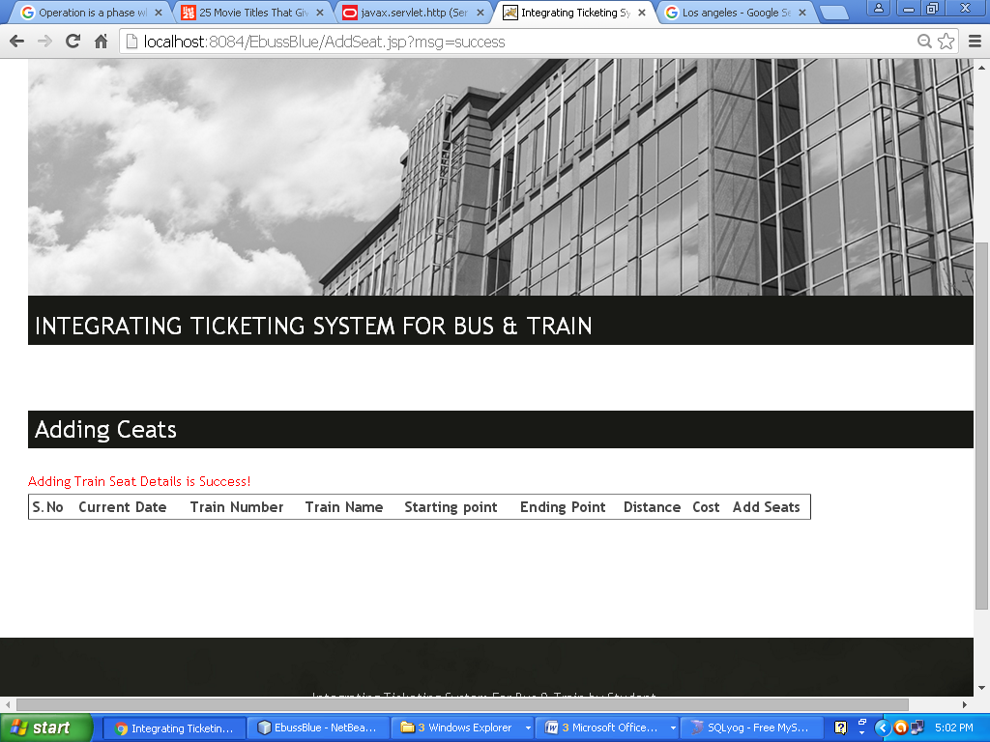

Adding Train Seat Success

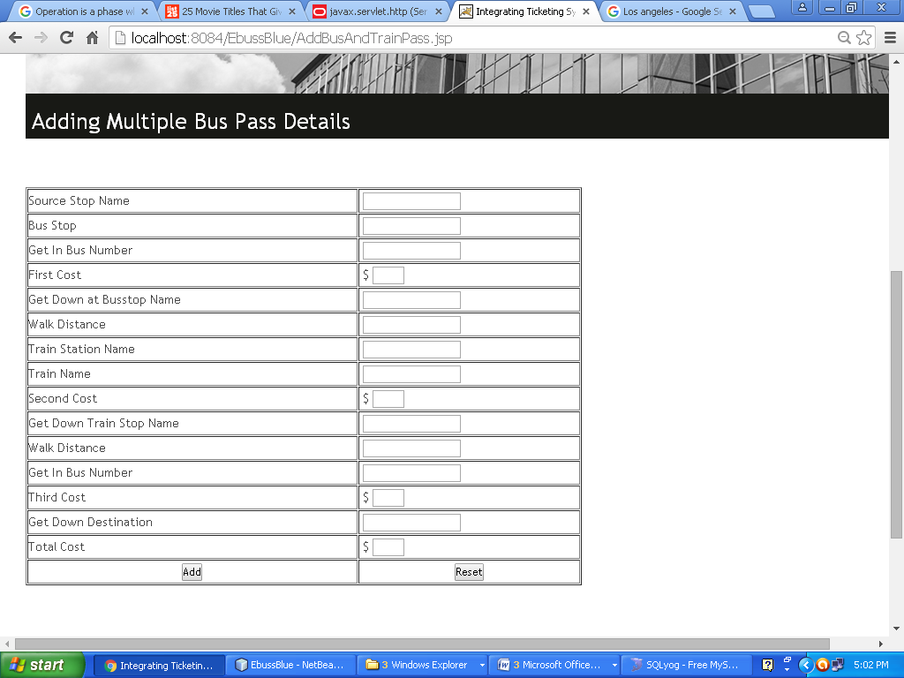

Adding Route pass data

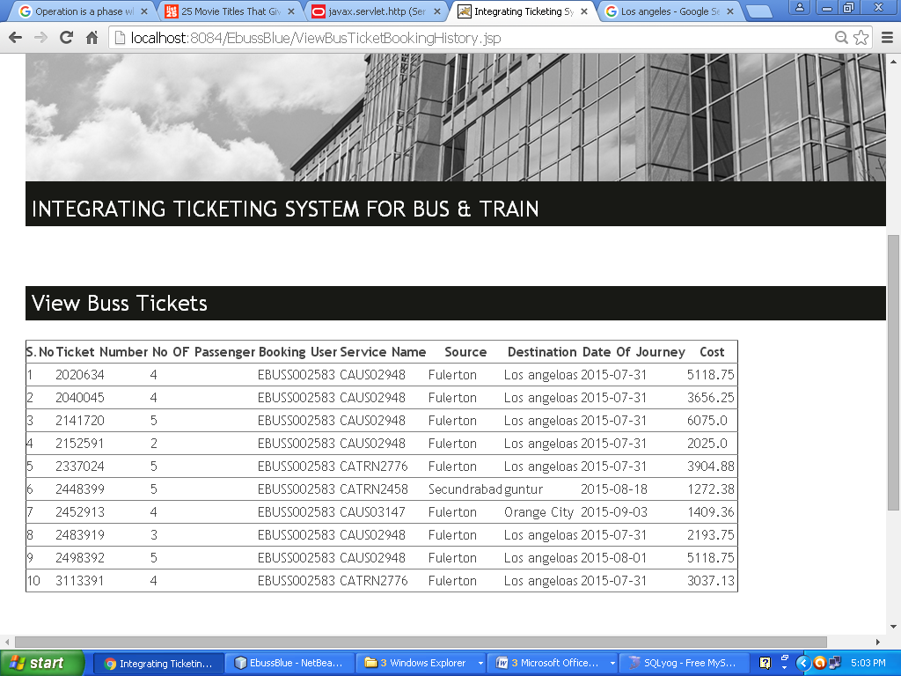View Train Tickets by admin

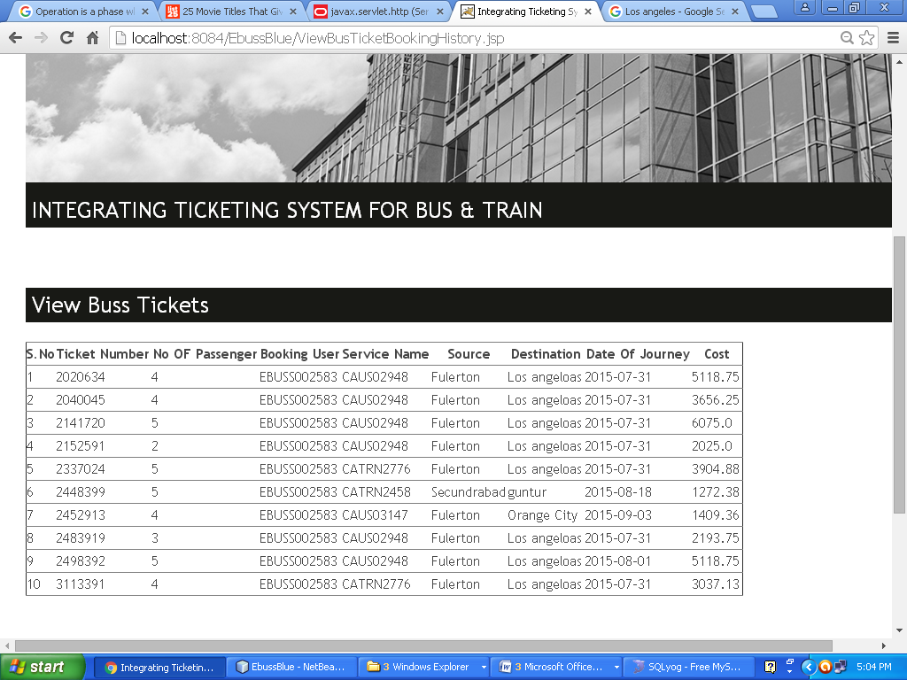View Bus Tickets by admin

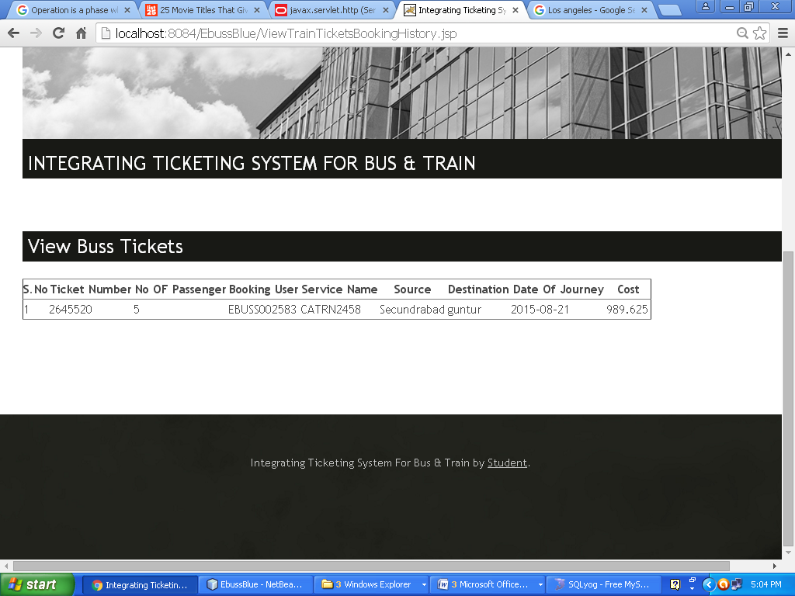

View Train Tickets

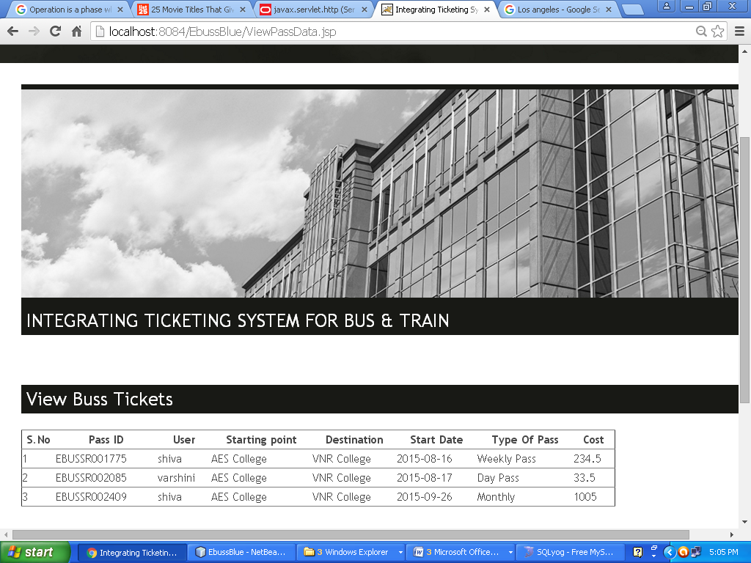

View Route pass by Admin

**7. CONCLUSION AND FUTURE ENHANCEMENT**

The package was designed in such a way that future modifications can be done easily. The following conclusions can be deducted from the development of the project.

* Automation of the entire system improves the efficiency.
* It provides a friendly graphical user interface which proves to be better when compared to the existing system.
* It gives appropriate access to the authorized users depending on their permissions.
* It effectively overcomes the delay in communications.
* Updating of information becomes so easier.
* System security, data security and reliability are the striking features.
* The system has adequate scope for modifications in future if it is necessary.

This application avoids the manual work and the problems concern with it. It is an easy and fast way to access the updates information.

**Future Enhancement:**

In future we will include various passes like Employees general passes, bus pass for specially challenged people and so on. We will also include bus timing along with routes and fares. We could be making an Android and iPhone application of this application so that the users can download this application and use this easily.

**8. BIBLIOGRAPHY**

* The Complete Reference Java

- Herbert Schildt

* www.java.com
* www.oracle10g.com
* www.google.com